

**ITES**

Participant’s Guide

**Functional Skills Training**

**ITES Functional Skills Training**

Participant’s Guide

|  |  |  |  |
| --- | --- | --- | --- |
| Version | Date | Author | Change Status |
| 1.0 |  |  |  |

|  |  |  |  |
| --- | --- | --- | --- |
| Version | Date | Author | Change Status |
| 1.0 |  |  |  |

**TABLE OF CONTENTS**

LEGEND 6

SESSION SCHEDULE 7

TOPIC 1 – SESSION INTRODUCTION 9

SUBTOPIC 1: PARTICIPANTS’ INTRODUCTION 9

TOPIC 2 – INTRODUCTION TO CSS 13

SUBTOPIC 1: WHAT IS CSS? 13

SUBTOPIC 2: IN THIS SESSION – SESSION OBJECTIVES 14

SUBTOPIC 3: ASSUMPTIONS 15

SUBTOPIC 4: REQUIREMENTS 16

SUBTOPIC 5: FREQUENTLY ASKED QUESTIONS (FAQs) 19

TOPIC 3 – DEFINING STYLES 20

SUBTOPIC 1: WHY USE CSS? 21

SUBTOPIC 2: WHY DEFINE CSS? 22

SUBTOPIC 3: CSS SYNTAX 25

SUBTOPIC 4: SELECTORS 27

SUBTOPIC 5: WEB PAGE WITH CSS 28

SUBTOPIC 6: INHERITENCE 29

TOPIC 4 – CSS PROPERTIES 30

SUBTOPIC 1: TEXT 31

SUBTOPIC 2: FONT 41

SUBTOPIC 3: BACKGROUND 46

SUBTOPIC 4: PADDING 47

SUBTOPIC 5: BORDER 48

SUBTOPIC 6: LIST 49

SUBTOPIC 7: LINKS 51

SUBTOPIC 8: CREATING A STYLE SHEET 53

SUBTOPIC 9: TYPES OF STYLE SHEETS 56

SUBTOPIC 10: TABLE 57

TOPIC 5 – PAGE LAYOUT 60

SUBTOPIC 1: POINTS TO CONSIDER 60

SUBTOPIC 2: PAGE SIZE AND SCREEN RESOLUTION 61

SUBTOPIC 3: DESIGNING PAGES 62

SUBTOPIC 4: SKETCHING POSITION OF AN ELEMENT ON GRID 64

SUBTOPIC 5: CODING YOUR PAGE 65

TOPIC 6 – NAVIGATION IN CSS 66

SUBTOPIC 1: NAVIGATION ELEMENTS 66

TOPIC 7 – DESIGN CONSIDERATIONS 67

SUBTOPIC 1: TABLES 67

SUBTOPIC 2: HEADINGS 68

SUBTOPIC 3: SHADING ALTERNATE ROWS 69

SUBTOPIC 4: FORMS 71

TOPIC 8 – USING INLINE CSS 74

SUBTOPIC 1: WHAT IS AN INLINE CSS? 75

SUBTOPIC 2: HOW TO USE AN INLINE STYLE? 76

TOPIC 9 – USING INTERNAL CSS 77

SUBTOPIC 1: WHAT IS AN INTERNAL CSS? 78

SUBTOPIC 2: HOW TO USE AN INTERNAL CSS? 79

TOPIC 10 – USING EXTERNAL CSS 81

SUBTOPIC 1: WHAT IS AN EXTERNAL CSS? 82

SUBTOPIC 2: HOW TO USE AN EXTERNAL CSS? 84

SUBTOPIC 3: POINTS TO REMEMER 85

TOPIC 11 – MODULE SUMMARY 86

SUBTOPIC 1: RECAP 86

SUBTOPIC 2: FINAL TIPS AND SUMMARIZATION 87

LAB EXERCISES 88

The following legend explains the various icons used in this guide.

LEGEND

|  |  |
| --- | --- |
| Icon | Description |
|  | Approximate duration of each section |
|  | Project course screen |
|  | Discussion |
|  | Group Activity |
|  | Activity |
|  | Important |

|  |  |  |
| --- | --- | --- |
| **Topic**  SESSION SCHEDULE | **Sub-topic** | **Duration in minutes** |
| 1. Session Introduction | * Participants’ Introduction * Ice Breaker | 15 minutes |
| 1. Introduction to CSS | * What is CSS? * Session Objectives * Assumptions * Requirements * FAQs | 15 minutes |
| 1. Defining Styles | * Why use CSS? * Why define CSS? * CSS Syntax * Selectors * Web Page with CSS * Inheritence | 120 minutes |
| 1. CSS Properties | * Text * Font * Background * Padding * Border * List * Links * Creating a Style Sheet * Types of Style Sheets * Table | 5 minutes |
| 1. Page Layout | * Points to consider * Page Size and Screen Resolution * Designing Pages * Sketching Position of an Element on Grid * Coding Your Page | 5 minutes |
| 1. Navigation in CSS | * Navigation Elements | 10 minutes |
| 1. Design Considerations | * Tables * Headings * Shading Alternate Rows * Forms |  |
| 1. Using Inline CSS | * What is an Inline CSS? * How to Use an Inline Style? |  |
| 1. Using Internal CSS | * What is an Internal CSS? * How to Use an Internal CSS? |  |
| 1. Using External CSS | * What is an External CSS? * How to Use an External CSS? * Points to Remember |  |
| 1. Summary | * Recap * Final Tips and Summarization | 10 minutes |
| 1. Check Your Understanding |  |  |
| **Total duration** | | **75 minutes** |

# The ILT course will be projected.

TOPIC 1 – SESSION INTRODUCTION

SUBTOPIC 1: PARTICIPANTS’ INTRODUCTION

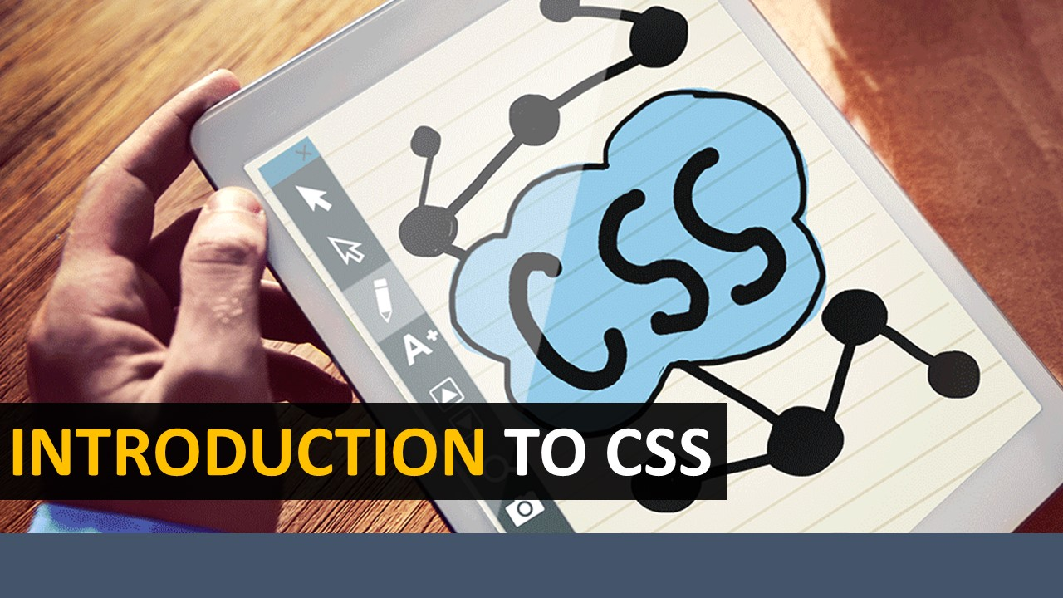



Take part in the activity described below:



**Describe your partner…**

* You will work in pairs for this activity.
* Once you have been divided into pairs, talk to your partner and learn interesting fact/details about him/her.
* Next, prefix your partner’s name with another word that describes him/her, or his/her hobby interest. The twist is that the initial letter of your partner’s name must be the initial letter of the characteristic. For example: *Fabulous Farheen, Adventurous Alia.*

**Your Space:**

|  |
| --- |
|  |
|  |
|  |
|  |
|  |

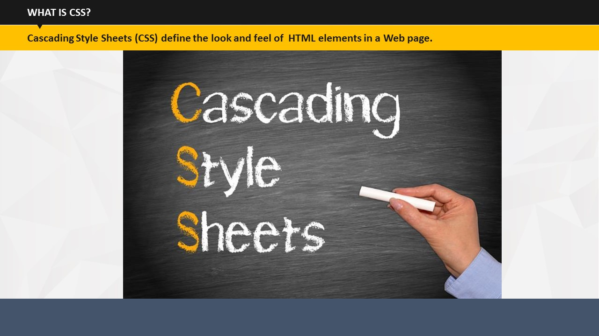

SUBTOPIC 1: WHAT IS CSS?

TOPIC 1 – SESSION INTRODUCTION

* Have you ever come across such sites on Internet that caught your attention due to their design, color combinations, layouts, choice of fonts etc.?
* So, what could be the reasons behind the impressive presentation of content on these and many more such sites? We can definitely say a talented web designer with wonderful visualization skills! But a CSS is equally necessary to give a nice look and feel to the content presentation on the websites.
* So, what exactly is CSS and how does it helps web designer?
* CSS or Cascading Style Sheets are used to define the look and feel of HTML elements in a webpage. In other words, CSS is a simple language used to write certain formatting instructions. These instructions are picked up by the browsers to define the look and feel of the webpages.

**Your Space:**

|  |
| --- |
|  |
|  |

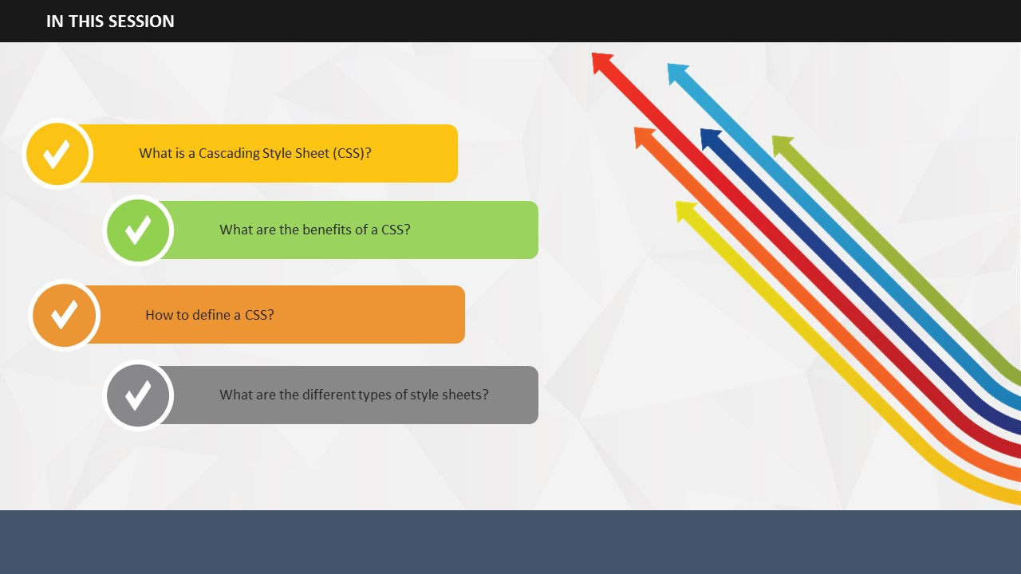

SUBTOPIC 2: IN THIS SESSION – SESSION OBJECTIVES

* In this session, you will learn what exactly CSS is.
* You will also learn why the benefits of CSS.
* In addition, you will also learn how you can define a CSS.
* The session will also introduce you to the three types of style sheets.

**Your Space:**

|  |
| --- |
|  |
|  |
|  |
|  |
|  |
|  |
|  |

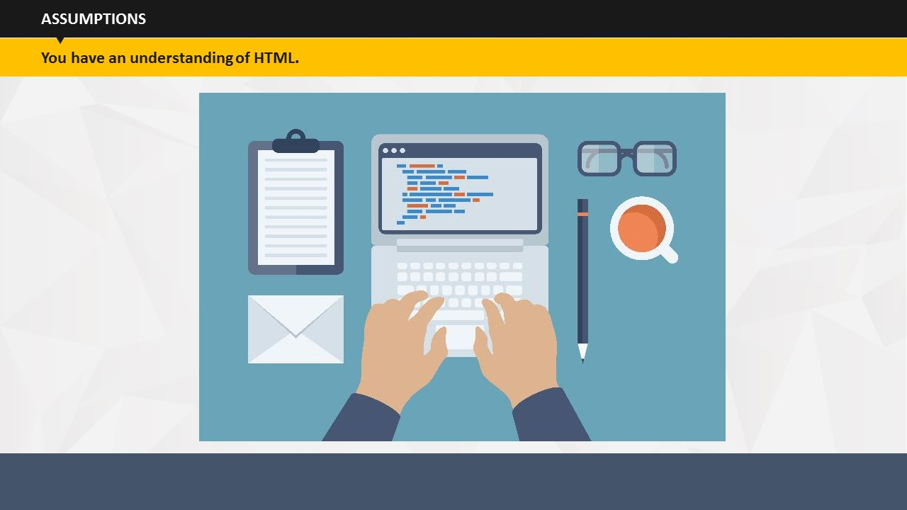

|  |
| --- |
|  |

SUBTOPIC 3: ASSUMPTIONS

To write a style sheet, it is important for you to have a working knowledge of HTML.

**Your Space:**

|  |
| --- |
|  |
|  |
|  |
|  |
|  |
|  |
|  |
|  |
|  |
|  |
|  |

## 

Before learning about HTML, it is extremely important that you know what tools are basically required for HTML writing. To continue with your understanding of HTML, you will obviously need a personal computer.

SUBTOPIC 4: REQUIREMENTS

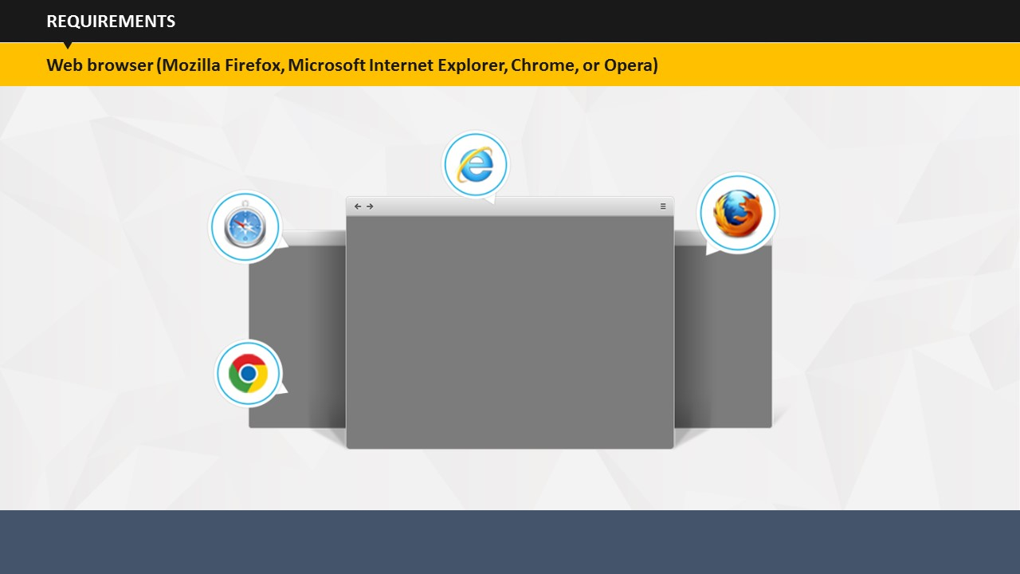

Along with a personal computer, you will also need a Web browser, such as Google Chrome, Mozilla Firefox, Internet Explorer, etc.

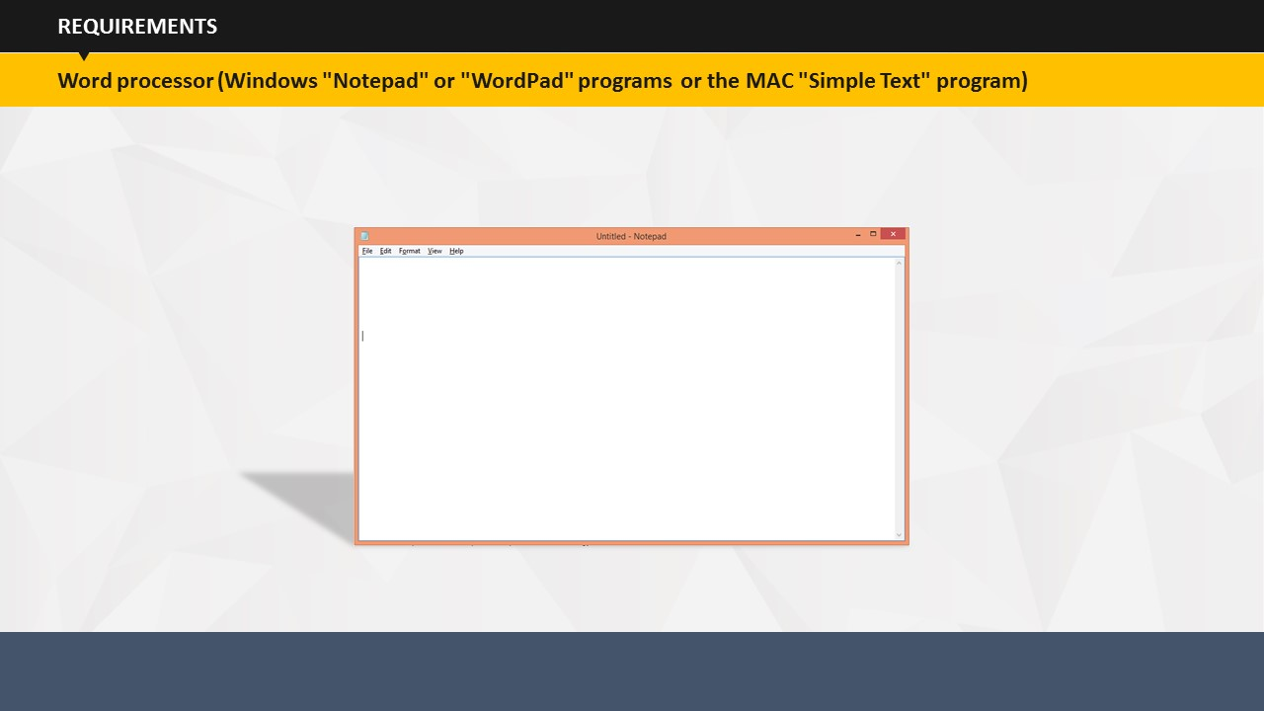

Now that you have a personal computer and a Web browser, the only thing needed now is a word processor. If you have access to Windows "Notepad" or "WordPad" programs or the MAC "Simple Text" program, you can use that to get started. Fortunately, HTML is written in plain text, which means that you don’t need any fancy software programs to create your HTML files.

**Your Space:**

|  |
| --- |
|  |
|  |
|  |
|  |
|  |
|  |
|  |
|  |
|  |
|  |
|  |
|  |

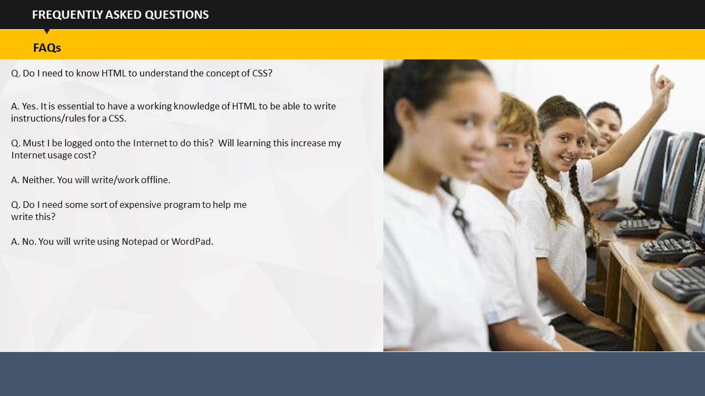

SUBTOPIC 5: FREQUENTLY ASKED QUESTIONS (FAQS)

Q1: Do I need to know HTML to understand the concept of CSS?  
A1: Yes. It is essential to have a working knowledge of HTML to be able to write instructions/rules for a CSS.

Q2Must I be logged onto the Internet to do this? More specifically, will learning this increase my Internet usage cost?  
A2: Neither. You will write or work offline.

Q3: Do I need some sort of expensive program to help me write this?  
A3: No. You can write using Notepad or WordPad.

**Your Space:**

|  |
| --- |
|  |
|  |
|  |
|  |
|  |

TOPIC 3 – DEFINING STYLES

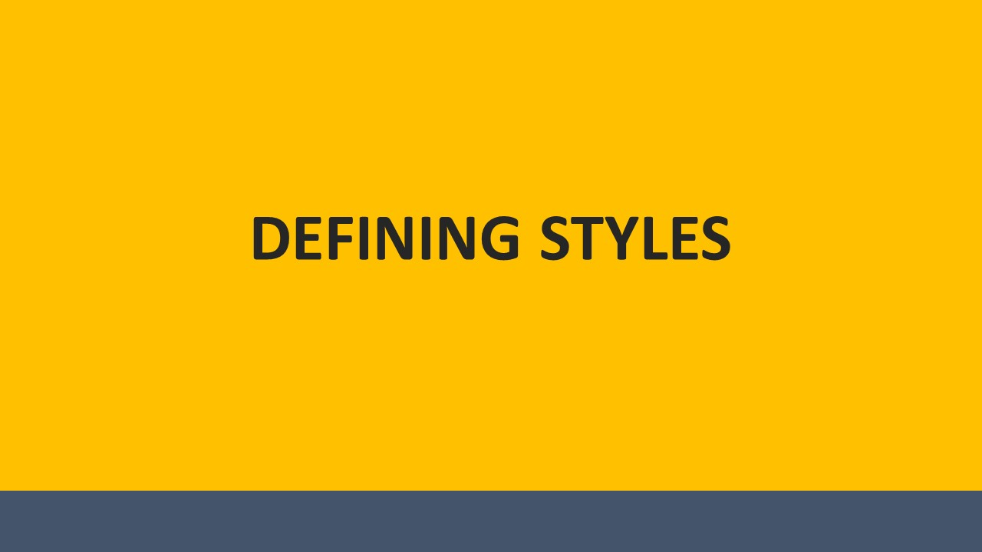

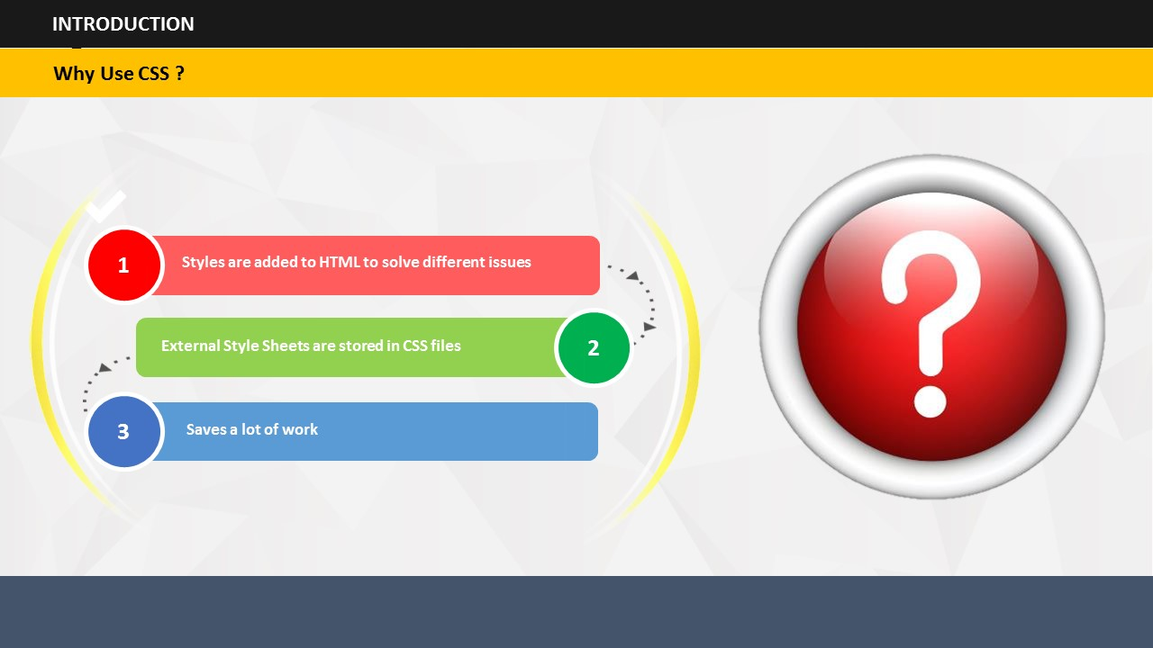

Styles are added to HTML to solve different issues

SUBTOPIC 1: WHY USE CSS?

External Style Sheets are stored in CSS files

Saves a lot of work

**Your Space:**

|  |
| --- |
|  |
|  |
|  |
|  |

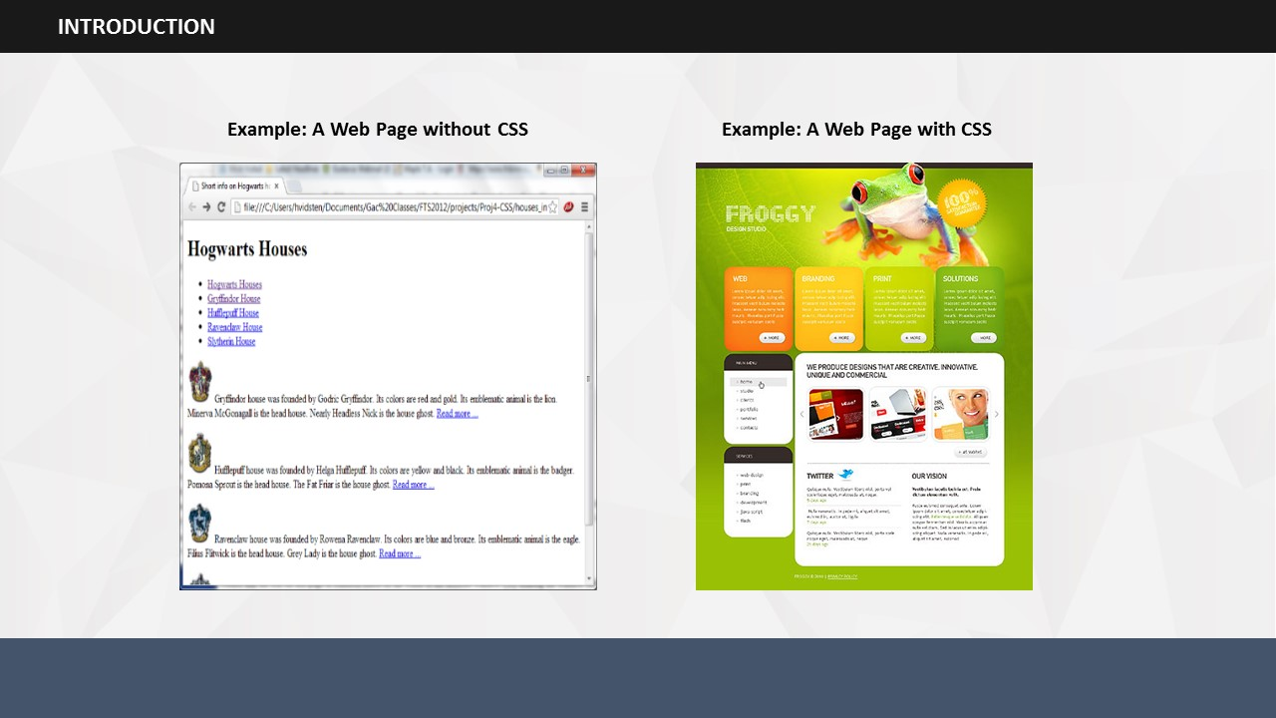See how a Web page looks with and without CSS.

Observe and note the differences between the two.

**Your Space:**

|  |
| --- |
|  |
|  |
|  |
|  |
|  |
|  |

SUBTOPIC 2: WHY DEFINE CSS?

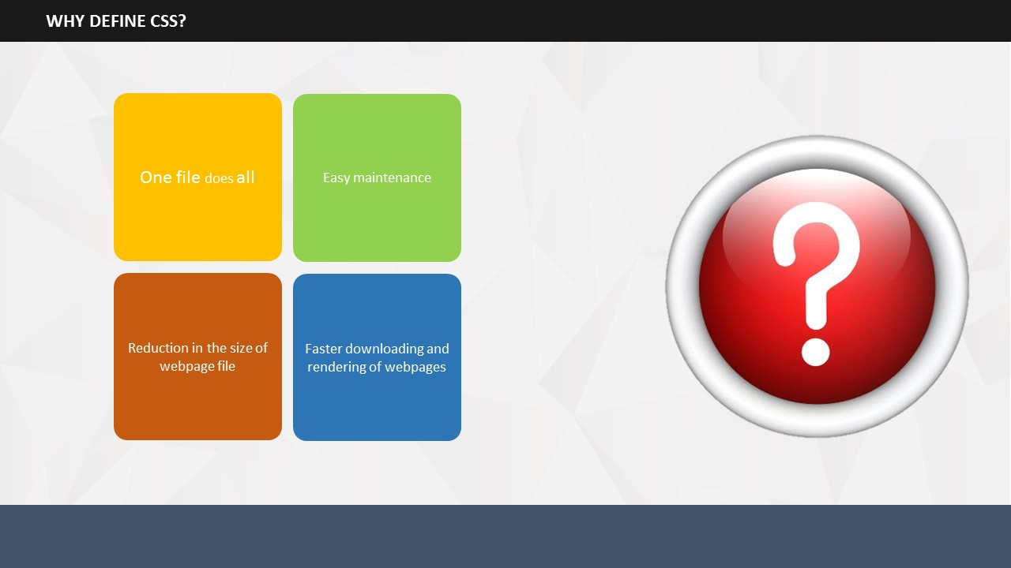

* Why is it important to define style sheets?
* The reasons behind defining CSS are definitely more than one.
  + - **One file does all**: HTML files arrange the content in a website, but the presentation of this content using different fonts, colors, formatting, background & so on is done using a CSS. So, you can provide style instructions in a single file that is separate to the HTML. On linking all the pages of your website to this centralized style sheet, you can easily update the look of the website.   
        
      For example, if you wish to change the font style of the headings, you can add the instructions in the style sheet. One rule will change the font style of all the headings on all the pages.
    - **Easy maintenance**: Since CSS requires fewer codes to manage the content, so less time is spent in addition or deletion of content. Moreover, fewer codes mean a lesser chance of coding errors!
    - **Device-based customized presentation**:You can use different set of rules for different devices in style sheets. For example, you can set different rules to manage how a webpage should appear when accessed from a desktop and from a mobile phone.
    - **Reduction in the size of webpage file**: Since the code required to style content is in a single file, so you may no longer need the codes on individual webpages. You can easily delete individual web page codes and reduce the size of the webpage file.
    - **Faster downloading and rendering of webpages**: If a user has once visited your website, CSS typically gets downloaded and saved in user’s computer in cache. So, when the user revisits the site only the HTML is downloaded leading to faster download of the webpage. The webpage can be made to render faster by writing simple rules or instructions in the style sheets. This enhances the user experience by displaying the webpage faster.

**Your Space:**

|  |
| --- |
|  |
|  |
|  |
|  |
|  |
|  |
|  |
|  |
|  |
|  |
|  |
|  |

## 

**SUBTOPIC 3: CSS SYNTAX**

1. A CSS rule or style has two parts.
2. Selector
3. Property: Value Pair (Declaration)
4. CSS selectors are used to select the HTML elements. These elements can be manipulated using CSS codes.
5. While writing a declaration, you can write one or more declarations separated by semicolons. The group of declarations is generally called as a declaration block.
6. Examples:  
   * p {color: blue; text-align: left;}  
       
     p is the selector while rest of the part is the declaration consisting of two properties, color and alignment and their corresponding values, blue and left.
   * h1 {color: black; font-size: 14px;}

Heading is set to black color and font size 14.

* + p {background-color: #e0ffff; font-family: Times New Roman;}  
      
    Paragraph property is set to a colored background and Times New Roman.

1. A few important guidelines to follow are:

* Always use semicolons to separate out multiple declarations in the declaration block.
* Always end a declaration with a semicolon.
* Start and end a declaration group by curly brackets.

**Your Space:**

|  |
| --- |
|  |
|  |
|  |
|  |
|  |
|  |
|  |
|  |
|  |
|  |
|  |
|  |

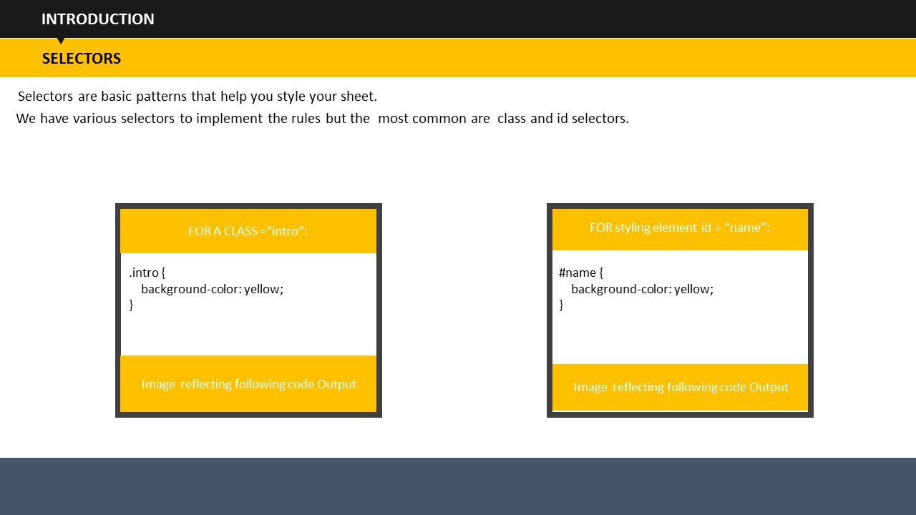

## 

SUBTOPIC 4: SELECTORS

Selectors are basic patterns that help you style your sheet.

We have various selectors to implement the rules but the most common are class and id selectors.

**Your Space:**

|  |
| --- |
|  |
|  |
|  |
|  |
|  |
|  |

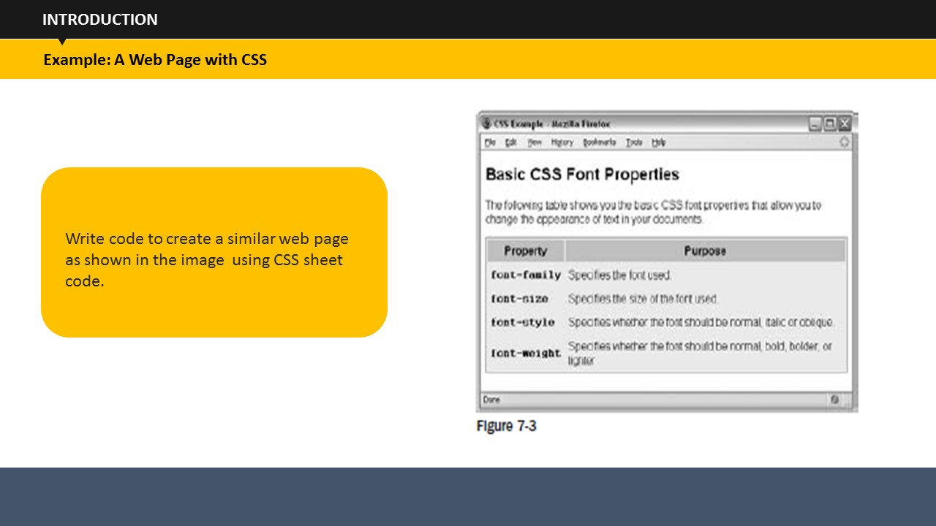

SUBTOPIC 5: WEB PAGE WITH CSS

**Say:** Let’s have a look at an example that shows how a set of CSS rules can transform the look of an XHTML page. CSS rules can live inside the XHTML document, although for this example we will be making a separate file to hold the CSS rules, and the XHTML page will contain a link to this file, which is known as a style sheet.

**Your Space:**

|  |
| --- |
|  |
|  |
|  |
|  |
|  |
|  |

## 

SUBTOPIC 6: INHERITENCE

**Say:** CSS properties that are set on an element through the cascade, can be inherited by the child elements of that element. For instance, if a div element has font-size 30px then, assuming that none of the font-size declarations have been explicitly defined, children will inherit that font-size value.

**Say:** For example, once the font - family property had been declared for the < body > element in the previous example, it applied to all of the elements inside the < body > element. This saves you from having to repeat the same rules for every single element that makes up a web page.

If another rule is more specific about which elements it applies to, then it will override any properties associated with the < body > element or any other containing element.

**Say:** The way in which some properties inherit saves you from having to write out rules and all the property -value pairs for each element and makes for a more compact style sheet.

## 

TOPIC 4 – CSS PROPERTIES

There are various types of properties associated with CSS. Once you are aware of these properties, you will be able to write a variety of CSS codes.

* These key properties are:

1. Text
2. Font
3. Background
4. Padding
5. Border
6. List
7. Links

**Your Space:**

|  |
| --- |
|  |
|  |
|  |
|  |

### 

SUBTOPIC 1: TEXT

While writing a CSS, you can style the text using various text formatting properties.

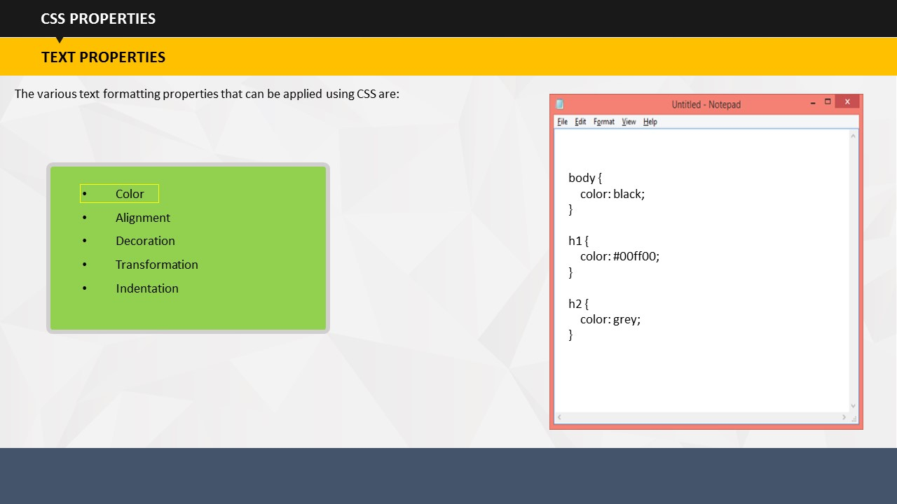

**TEXT COLOR**

The first property is color. You can set the color of the default page by defining the body selector.

The following style code shows that the default page text is set to blue color.

body {  
    color: black;  
}  
  
h1 {  
    color: #00ff00;  
}  
  
h2 {  
    color: grey;

}

Similarly, you can set heading colors.

**Your Space:**

|  |
| --- |
|  |
|  |
|  |
|  |
|  |
|  |
|  |
|  |
|  |
|  |

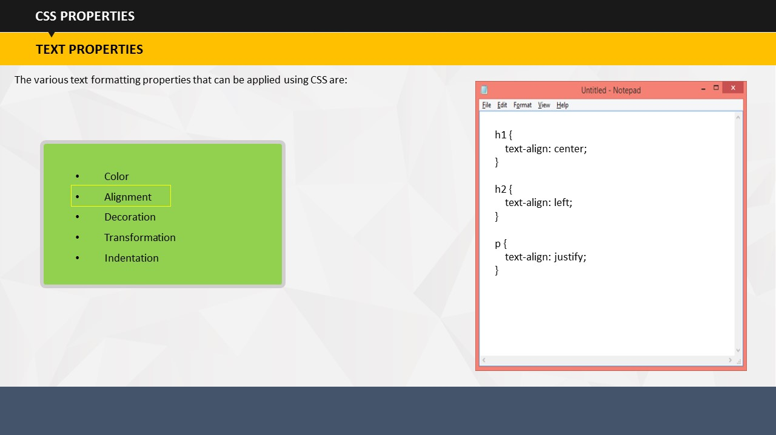**TEXT ALIGNMENT**

The second property is text alignment. You can use different styles to define the alignment of text.

Example:

h1 {  
text-align: center;  
}  
h2 {  
text-align: left;  
}  
p {  
text-align: justify;  
}

The style defined in the example shows that heading 1 should be center aligned, heading 2 should be left aligned, and paragraph text should be justified.

**Your Space:**

|  |
| --- |
|  |
|  |
|  |
|  |
|  |

**TEXT DECORATION**

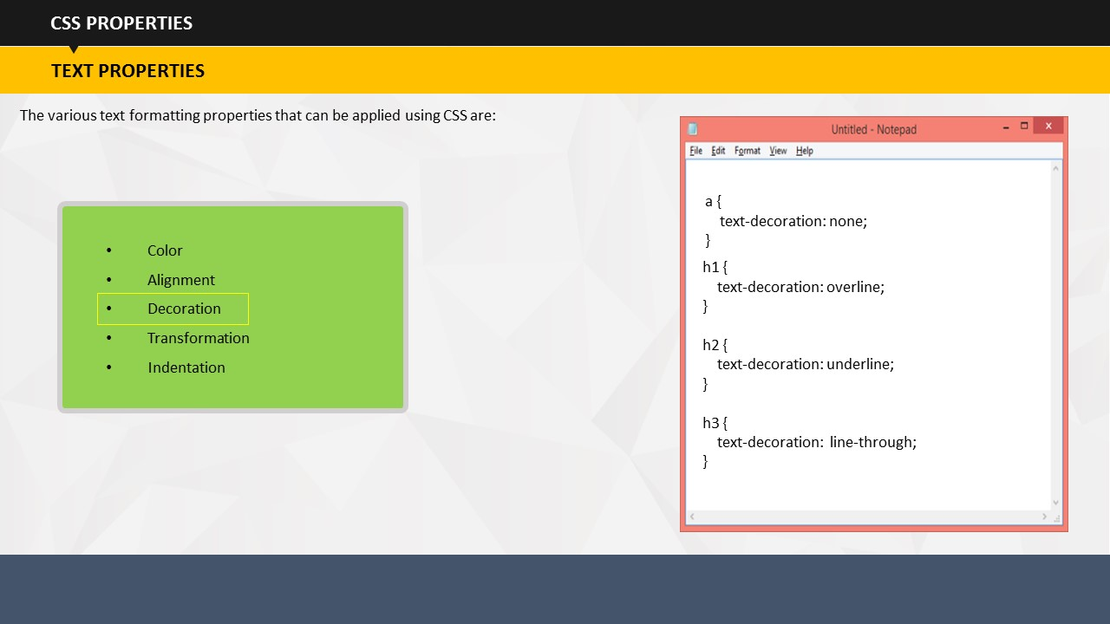

The decoration property is basically used for removing underline from hyperlinks. You can also use it to overline, underline and line-through the text.

a {  
    text-decoration: none;  
}

h1 {  
    text-decoration: overline;  
}  
  
h2 {  
    text-decoration: underline;  
}  
  
h3 {  
    text-decoration:  line-through;  
}

**Your Space:**

|  |
| --- |
|  |
|  |
|  |
|  |
|  |
|  |
|  |

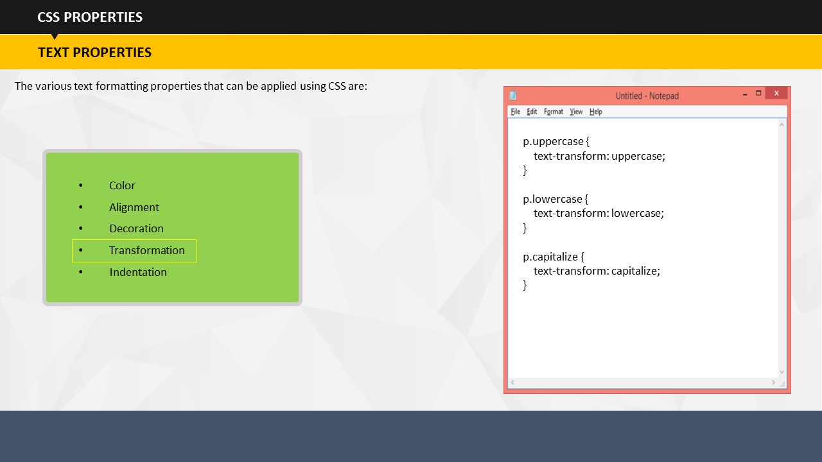**TEXT TRANSFORMATION**

The text transformation property is used to change the casing of the text. Using it, you can control if your text will appear in uppercase or lowercase letters. You can also set the code to capitalize the first letter of each word.

p.uppercase {  
    text-transform: uppercase;  
}  
  
p.lowercase {  
    text-transform: lowercase;  
}  
  
p.capitalize {  
    text-transform: capitalize;  
}

**Your Space:**

|  |
| --- |
|  |
|  |
|  |
|  |
|  |
|  |

**TEXT INDENTATION**

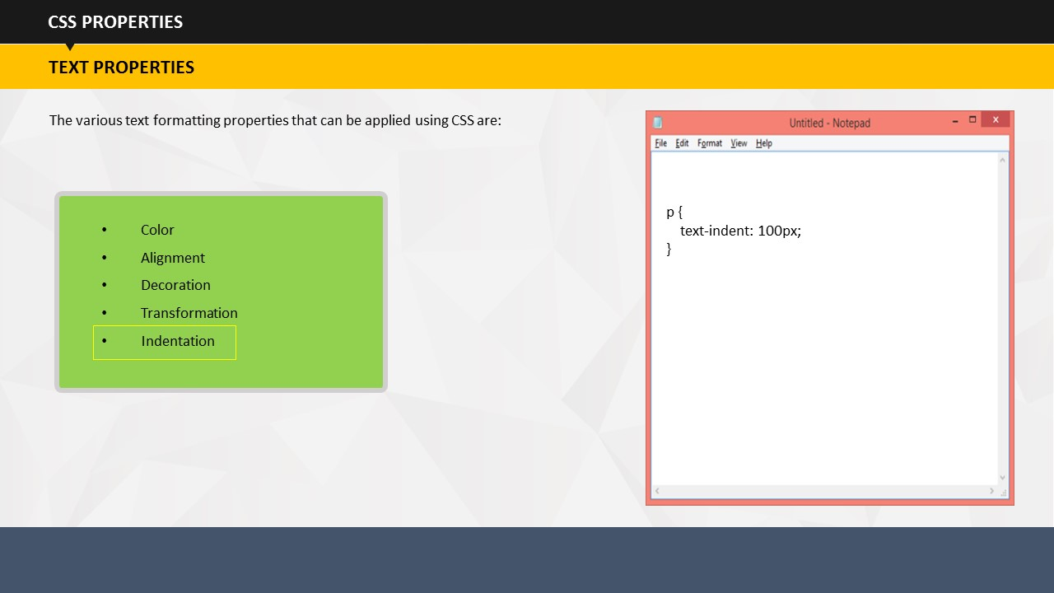The indentation property is used to set the indentation of the text, specifically of the first line of text.

The example code shows that the indentation is set at 100 pixels.

p {  
    text-indent: 100px;  
}

**Your Space:**

|  |
| --- |
|  |
|  |
|  |
|  |
|  |

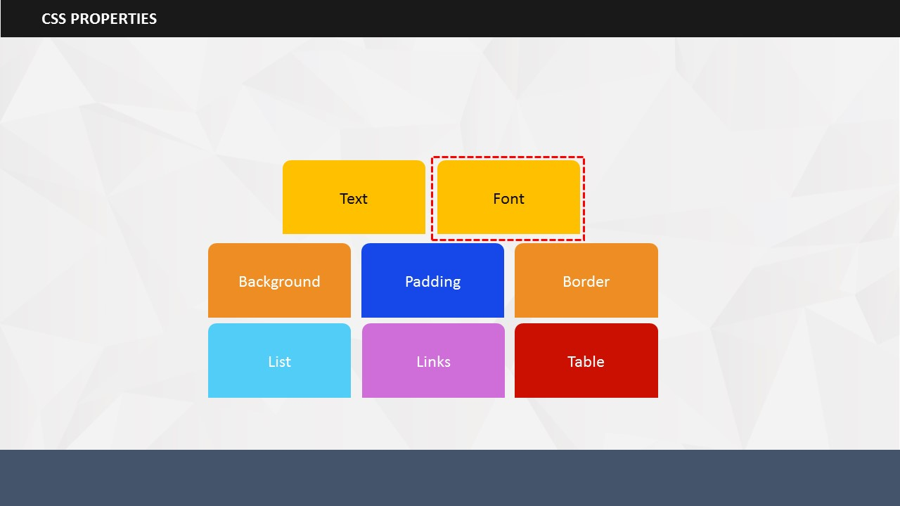

SUBTOPIC 2: FONT

Using font properties, you can set the font family, style, size and weight.

**Your Space:**

|  |
| --- |
|  |
|  |
|  |
|  |
|  |
|  |
|  |
|  |
|  |
|  |

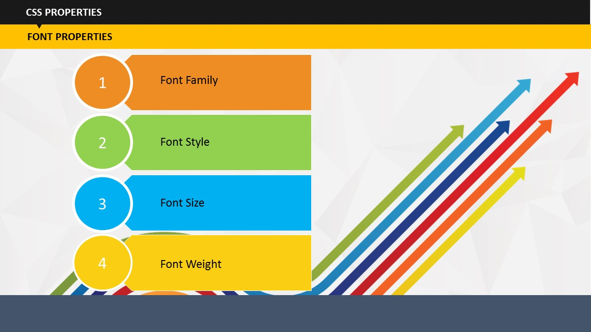

By using font family property, you can set the type of font. For example, Arial, Times New Roman, Calibri, and so on. An important point to take care of while setting font style is that the name of font should be placed in quotation marks if it is more than one word long. For example Times New Roman should be placed in quotation marks while Arial can be written without quotation marks.

**Your Space:**

|  |
| --- |
|  |
|  | |
|  | |
|  | |
|  | |
|  | |
|  | |

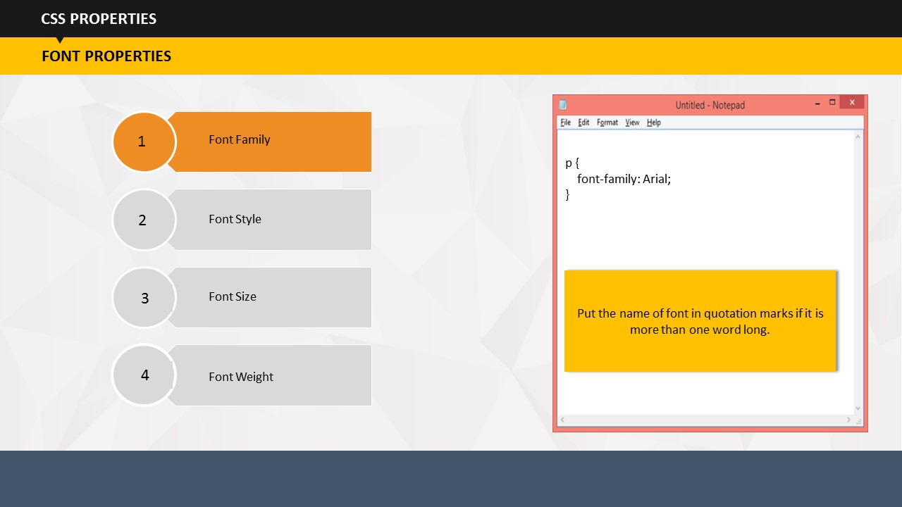

**FONT STYLE**

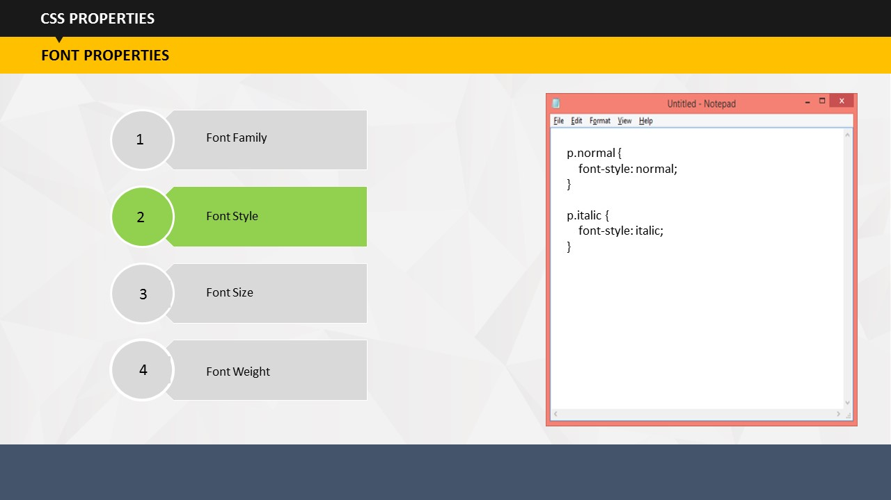

Using font style, you can decide if you would like the text to appear in normal or italics form.

**Your Space:**

|  |
| --- |
|  |
|  |
|  |

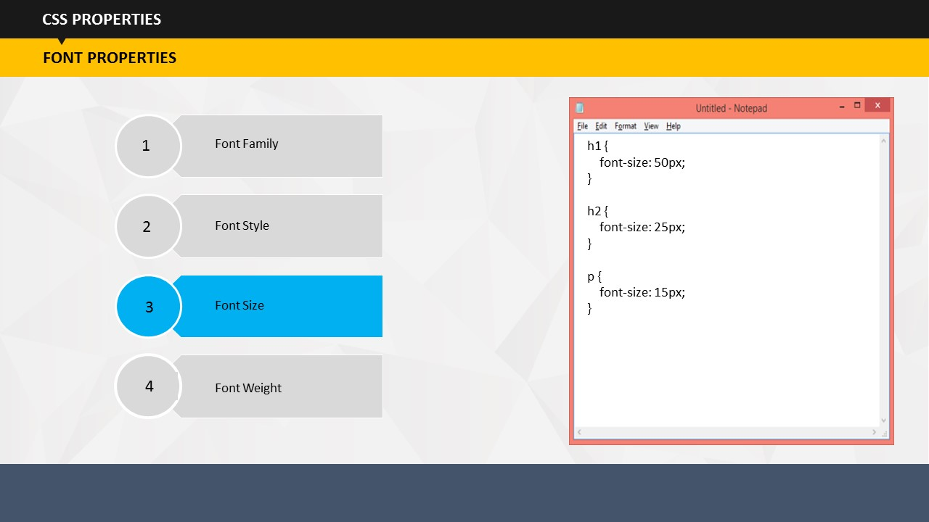**FONT SIZE**

You can set the size of headings, body text etc. using code for font size.

**Your Space:**

|  |
| --- |
|  |
|  |
|  |

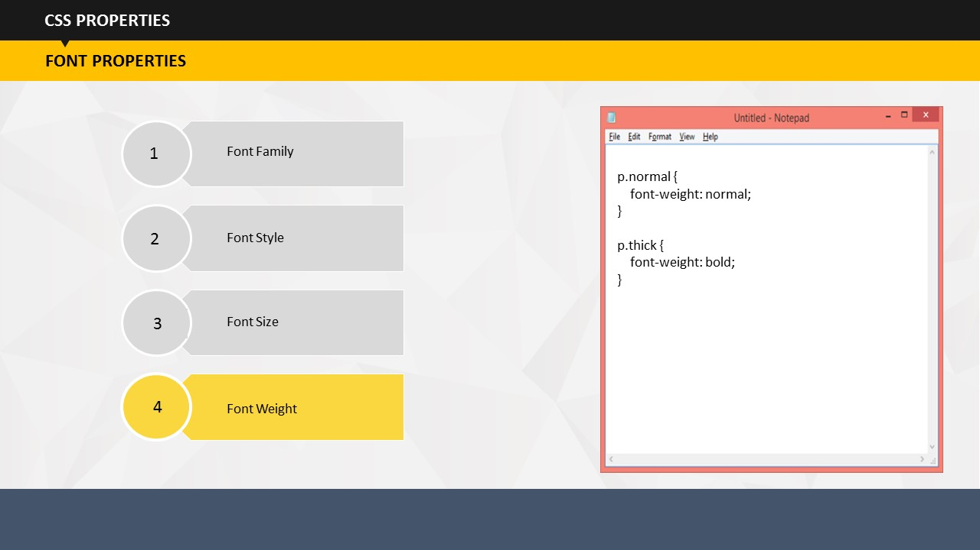**FONT WEIGHT**

Using code for font weight, you can define if you would like the text to appear as normal or in bold format.

**Your Space:**

|  |
| --- |
|  |
|  |
|  |
|  |
|  |
|  |
|  |
|  |
|  |
|  |

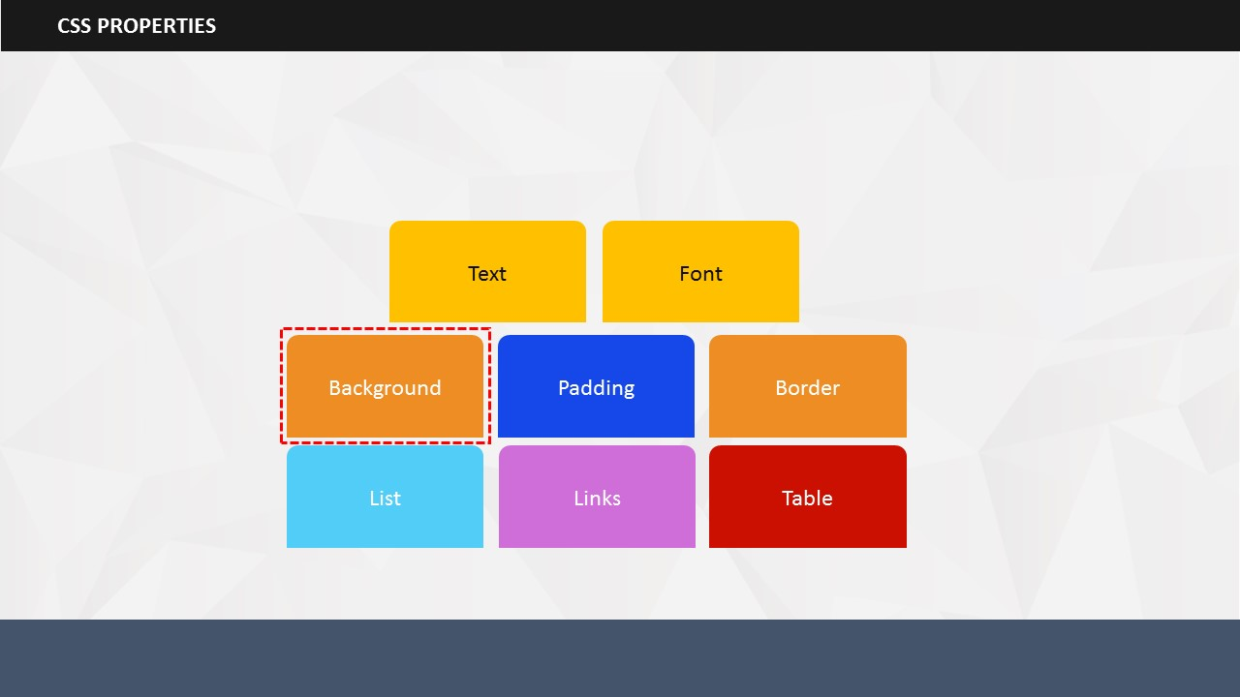

### Using CSS, you can easily manage the background color as well as background image

SUBTOPIC 3: BACKGROUND

* You can set background colors for the background of the page, heading and paragraph using different codes.
* Similarly, you can set an image to act as a background of your page. In addition, you can add one more code if you would like to repeat the image.
* If you do not want your background image to be repeated, you will have to add the no-repeat code.
* You can also fix the position of the image using background-position code.

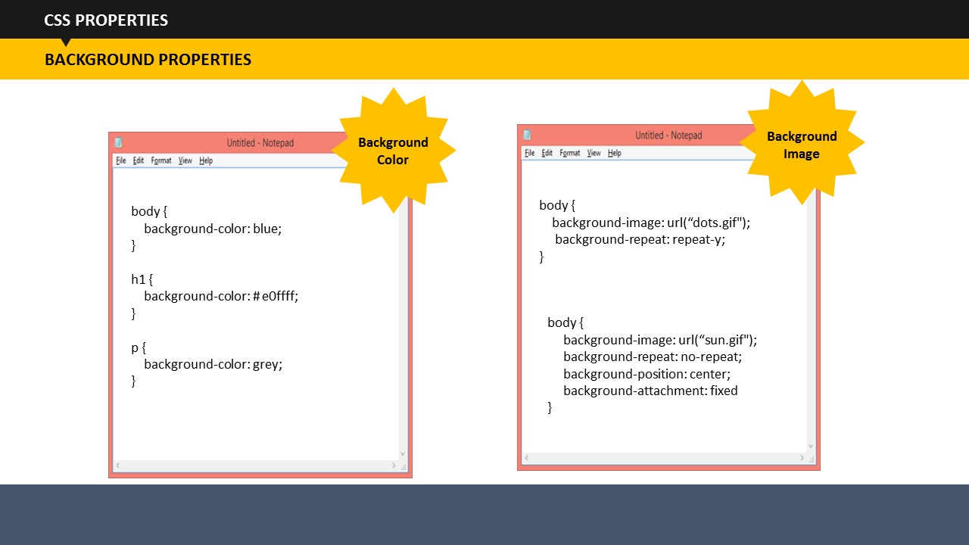

* The last property of background style is the background-attachment. You can set this property to decide if you would like your background image to be fixed or scrolled with the rest of the page.

**Your Space:**

|  |
| --- |
|  |
|  |
|  |
|  |
|  |

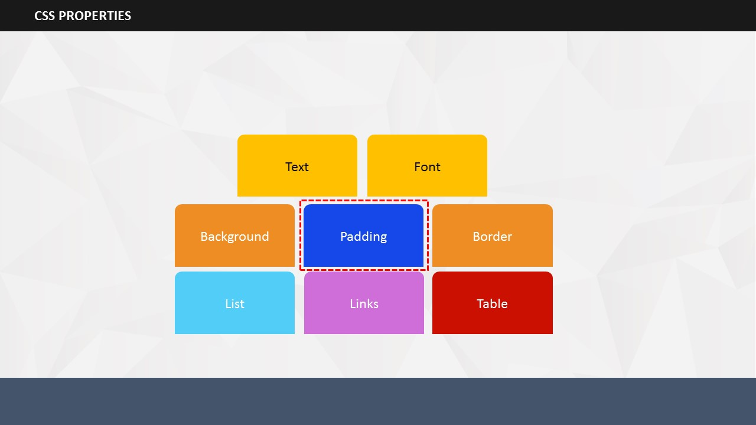

SUBTOPIC 4: PADDING

* Using CSS, you can define different padding for different sides.
* Padding is the space between the element content and the border around it. We can maintain this space using CSS. So, you can easily set the left, right, top, and bottom paddings using style codes as shown on the screen.

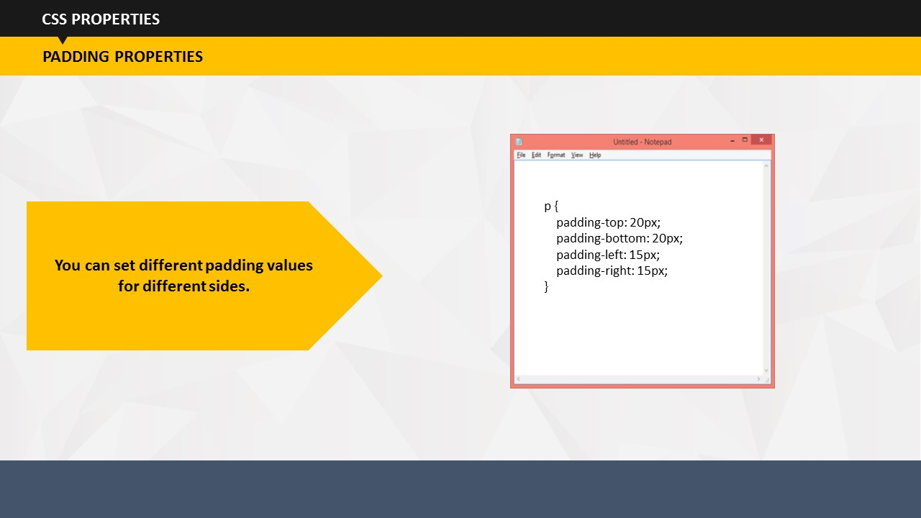

* You can set different padding values for different sides.

**Your Space:**

|  |
| --- |
|  |
|  |
|  |
|  |
|  |
|  |
|  |
|  |

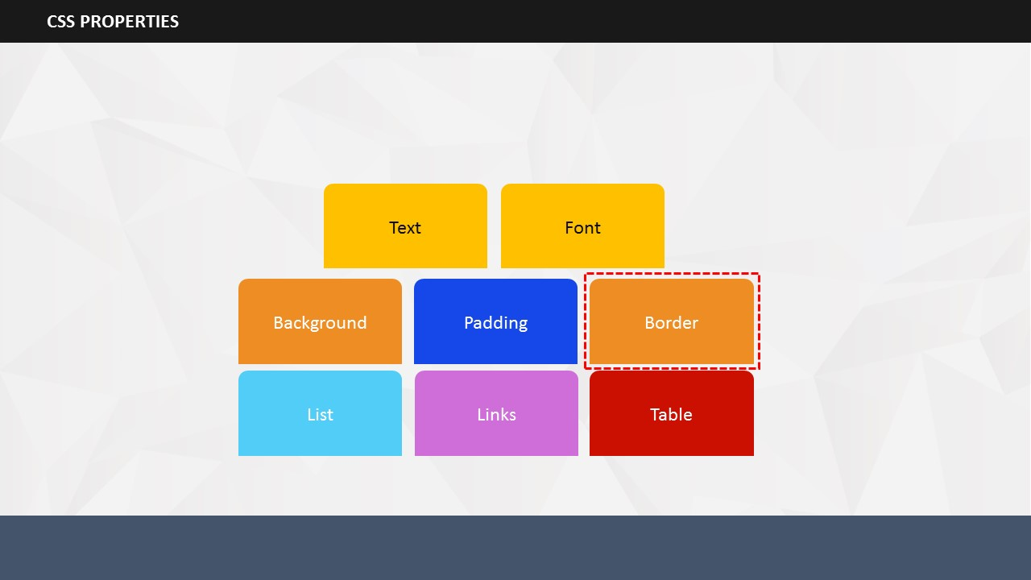

SUBTOPIC 5: BORDER

* You can specify the size, color and style of an element's border using border property. Border style here means that the border can be solid, dotted, dashed, double-lined, and so on.

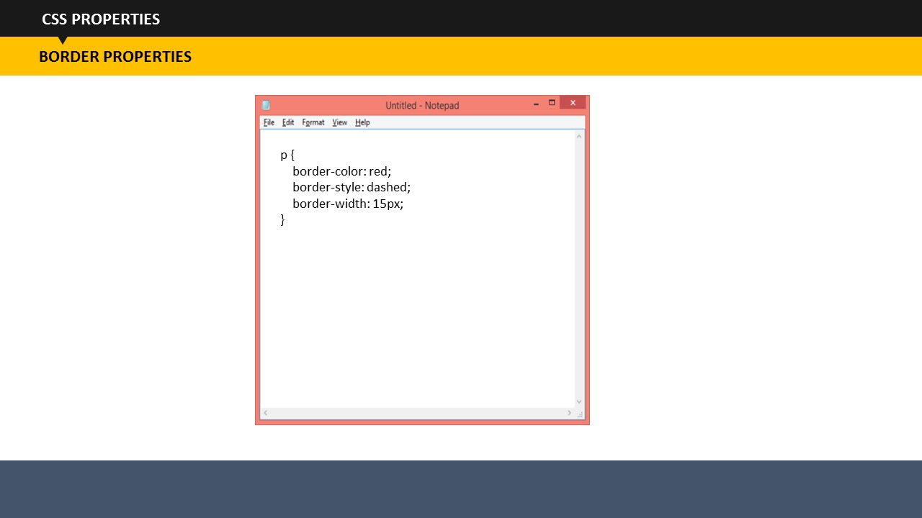

* The following example code shows that the border is of red color, dashed and with a width of 15 pixels:

p {  
    border-color: red;  
 border-style: dashed;  
    border-width: 15px;  
}

**Your Space:**

|  |
| --- |
|  |
|  |
|  |

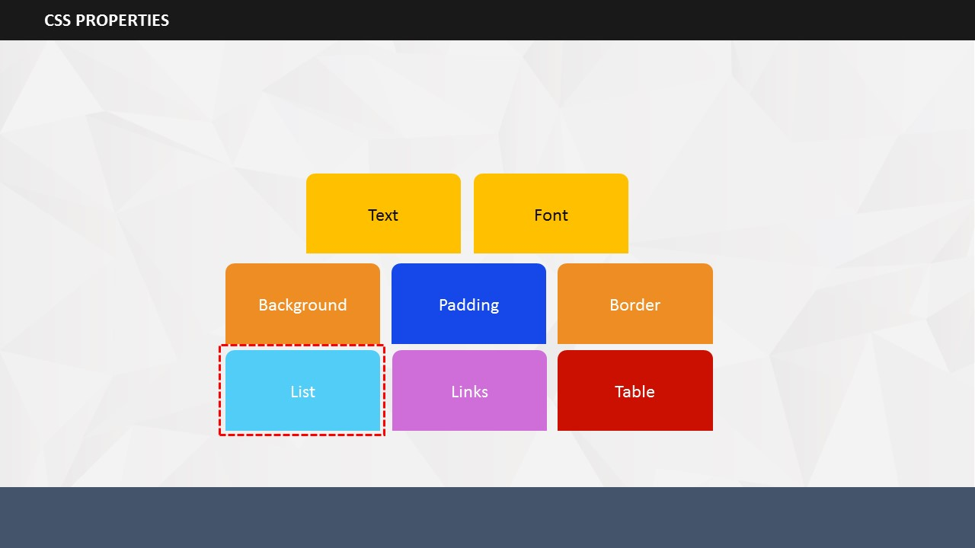

SUBTOPIC 6: LIST

* The List property helps in defining the list markers for ordered as well as unordered lists.
* In other words, it helps you decide if you would like all the ordered lists markers to appear in form of number or alphabets.

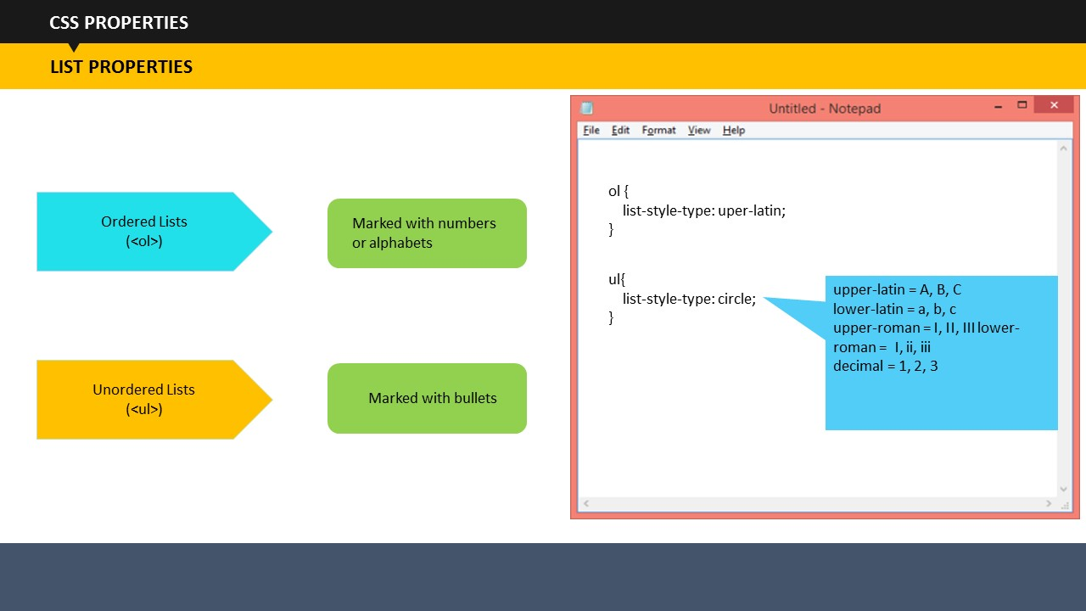

* Similarly, you can set how you would like the unordered list items to appear. You can use round circle, square and more such styles. Alternatively, you can also use an image as the list item marker.

**Your Space:**

|  |
| --- |
|  |
|  |
|  |
|  |
|  |
|  |
|  |

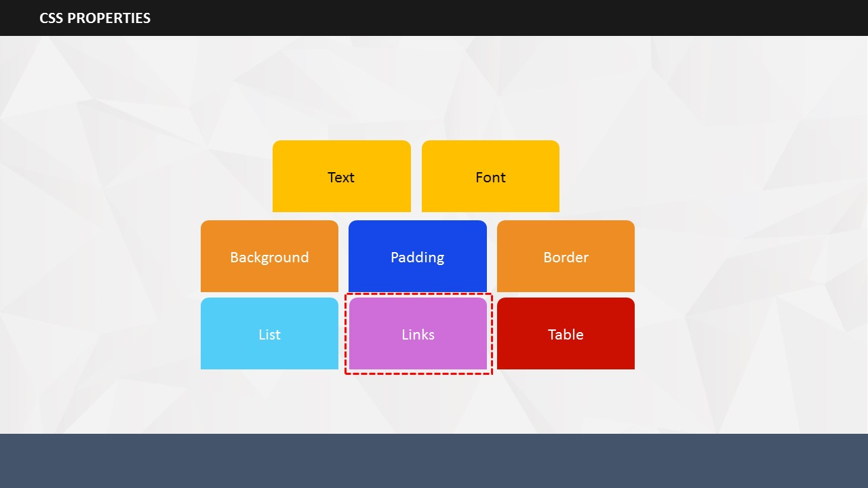

SUBTOPIC 7: LINKS

Links can be styled in many ways. The style depends on the state of a link, for example if it is unvisited or visited. Different styles are available if the link if the user hovers over the link using mouse. You can also set a separate style for the links which have been just clicked.

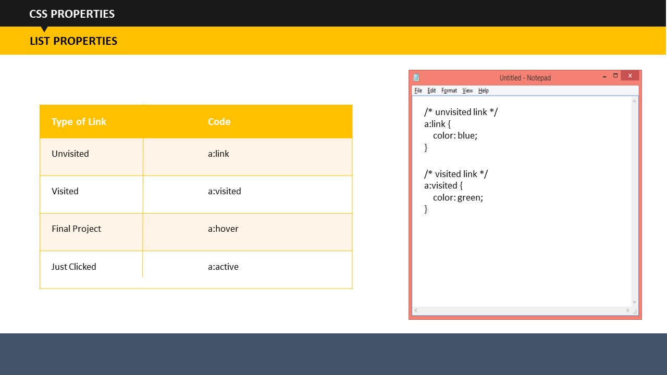

* The following code defines that unvisited links should be of blue color while the visited links should turn green:

/* unvisited link */  
a:link {  
    color: blue;  
}  
  
/* visited link */  
a:visited {  
    color: green;

}

**Your Space:**

|  |
| --- |
|  |
|  |
|  |
|  |

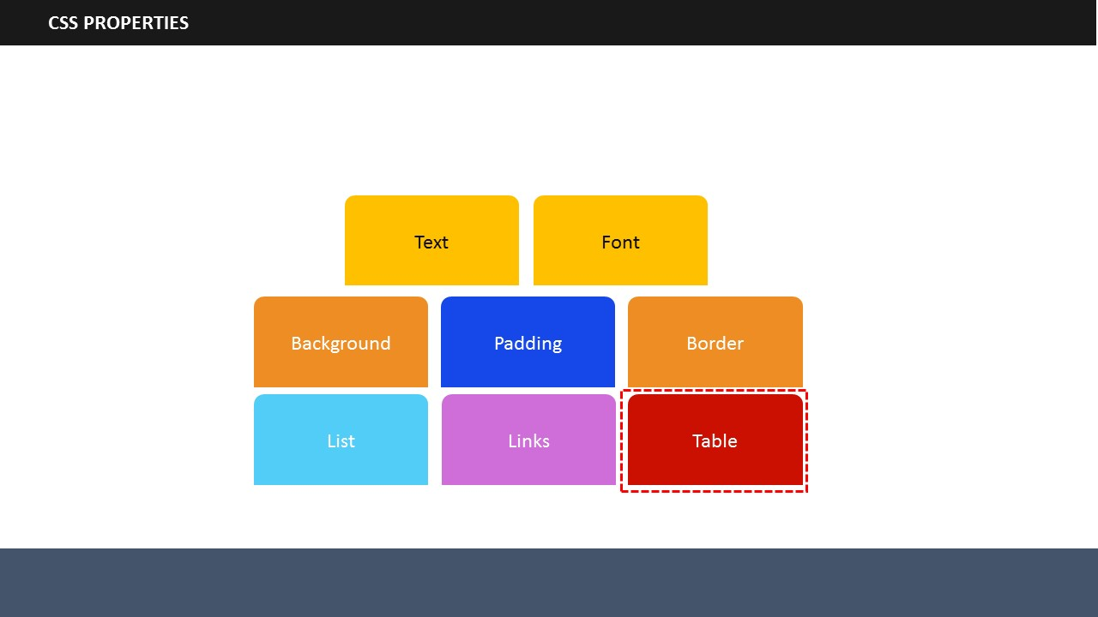

Let’s read about the table property.

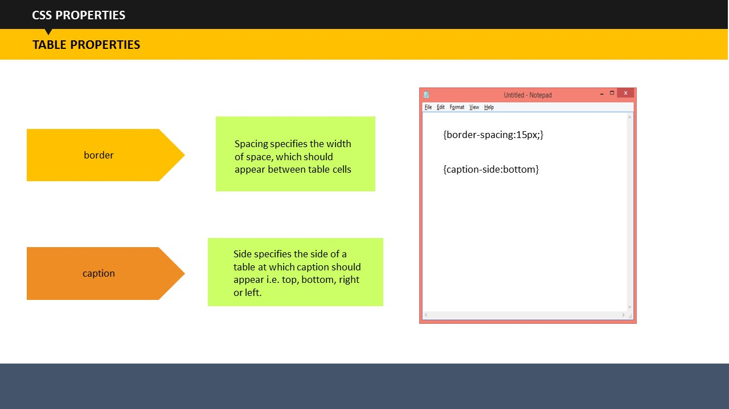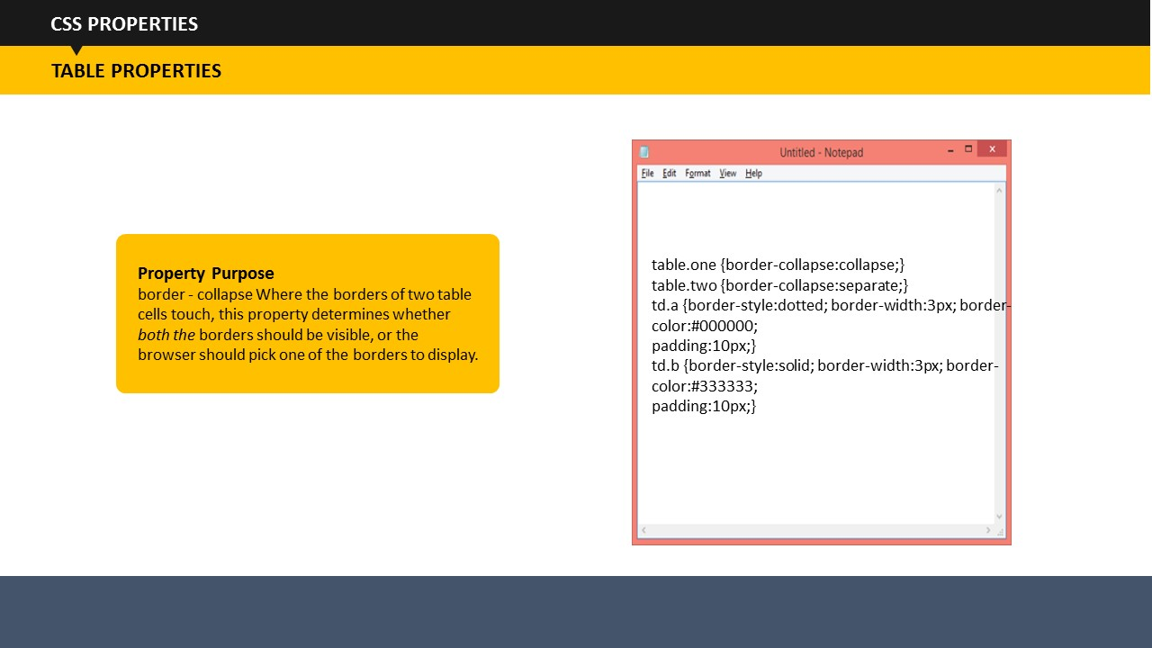

SUBTOPIC 8: TABLE

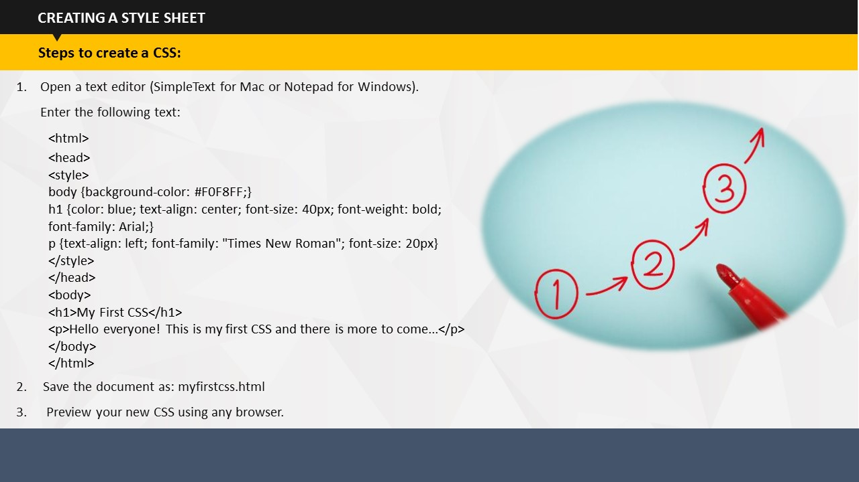

SUBTOPIC 8: CREATING A STYLE SHEET

Steps to create a new CSS:

* Open a text editor (SimpleText for Mac or Notepad for Windows).
* Enter the following text:

<html>

<head>

<style>

body {background-color: #F0F8FF;}  
h1 {color: blue; text-align: center; font-size: 40px; font-weight: bold; font-family: Arial;}  
p {text-align: left; font-family: "Times New Roman"; font-size: 20px}  
</style>  
</head>  
<body>  
<h1>My First CSS</h1>  
<p>Hello everyone! This is my first CSS and there is more to come...</p>  
</body>  
</html>

* Save the document as: *myfirstcss.html*. Your file can be saved as either an htm or html file. Remember to save your document on the computer in a place that you can find it

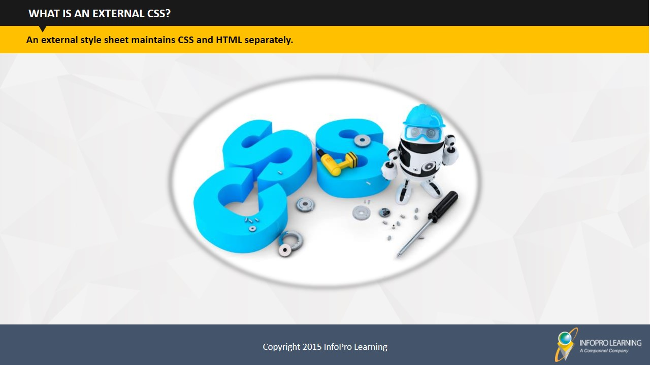again. 

* Preview your new CSS using any browser.

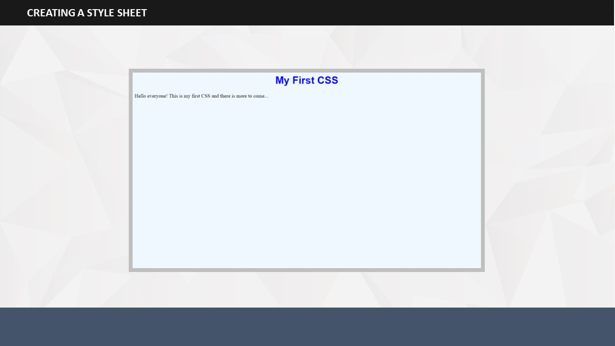

If all went as planned, your file should look like the given image in your browser. Congratulations! You have successfully completed your first CSS.

You can continue to build on this CSS by adding more styles to it.

**Your Space:**

|  |
| --- |
|  |
|  |
|  |
|  |
|  |
|  |
|  |
|  |
|  |
|  |
|  |
|  |
|  |
|  |
|  |
|  |
|  |
|  |
|  |

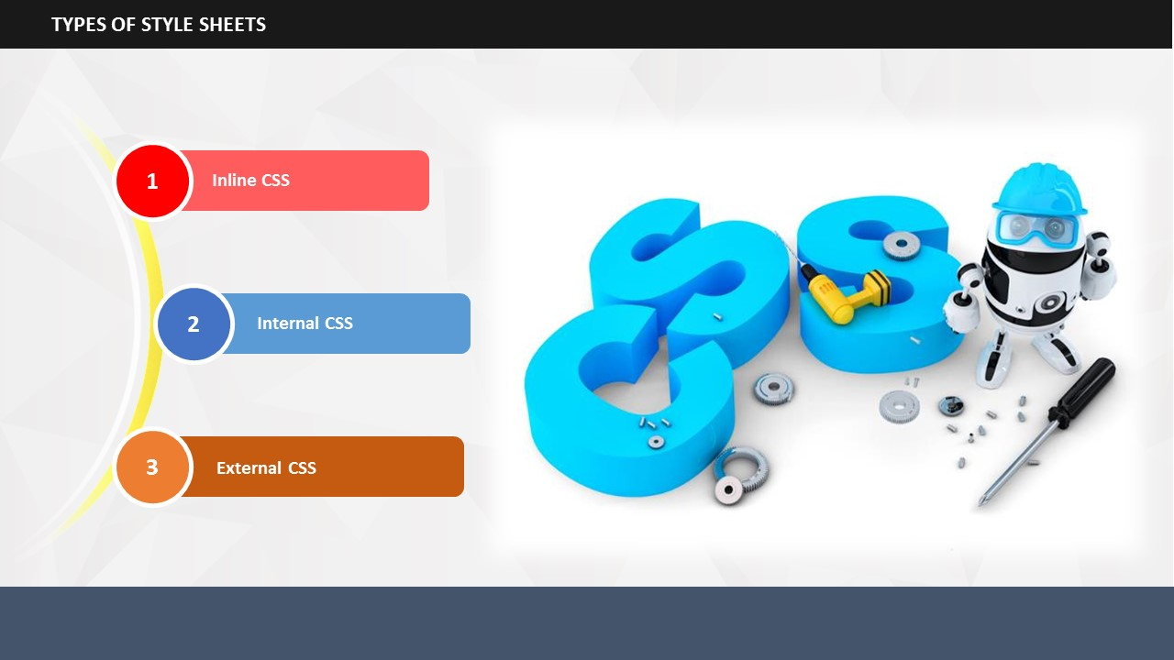

|  |
| --- |
|  |

SUBTOPIC 9: TYPES OF STYLE SHEETS

There are three types of style sheets – Inline, Internal, and External. We will learn about each style sheet and how it can be used.

**Your Space:**

|  |
| --- |
|  |
|  |
|  |
|  |

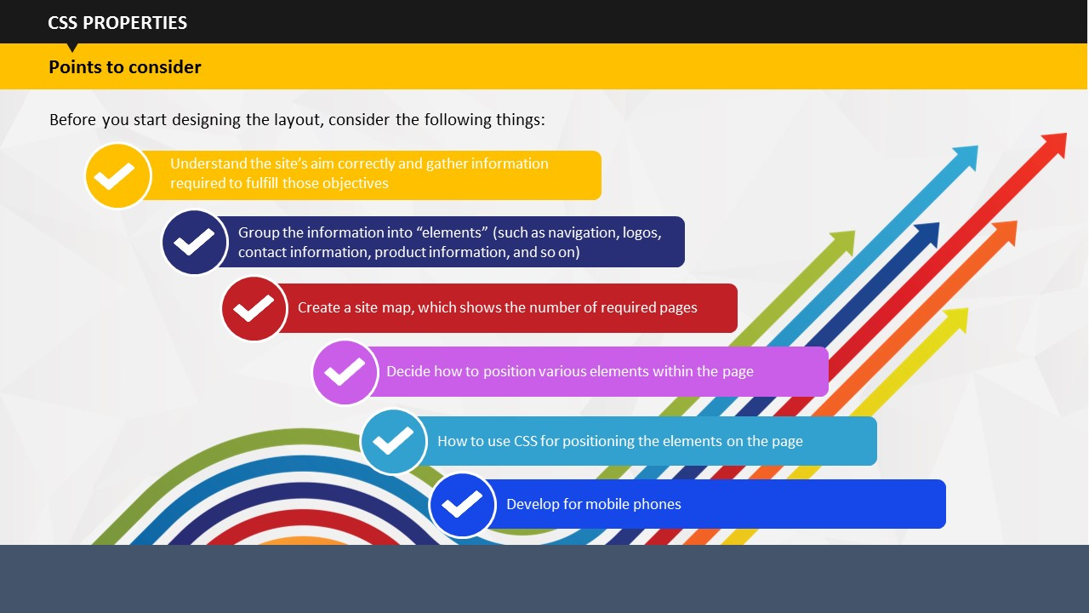

**Points to consider**

SUBTOPIC 1: POINTS TO CONSIDER

TOPIC 5 – PAGE LAYOUT

Understand the site’s aim correctly and gather information required to fulfill those objectives

Group the information into “elements” (such as navigation, logos, contact information, product information, and so on)

Create a site map, which shows the number of required pages

Decide how to position various elements within the page

How to use CSS for positioning the elements on the page

Develop for mobile phones

**Your Space:**

|  |
| --- |
|  |
|  |
|  |

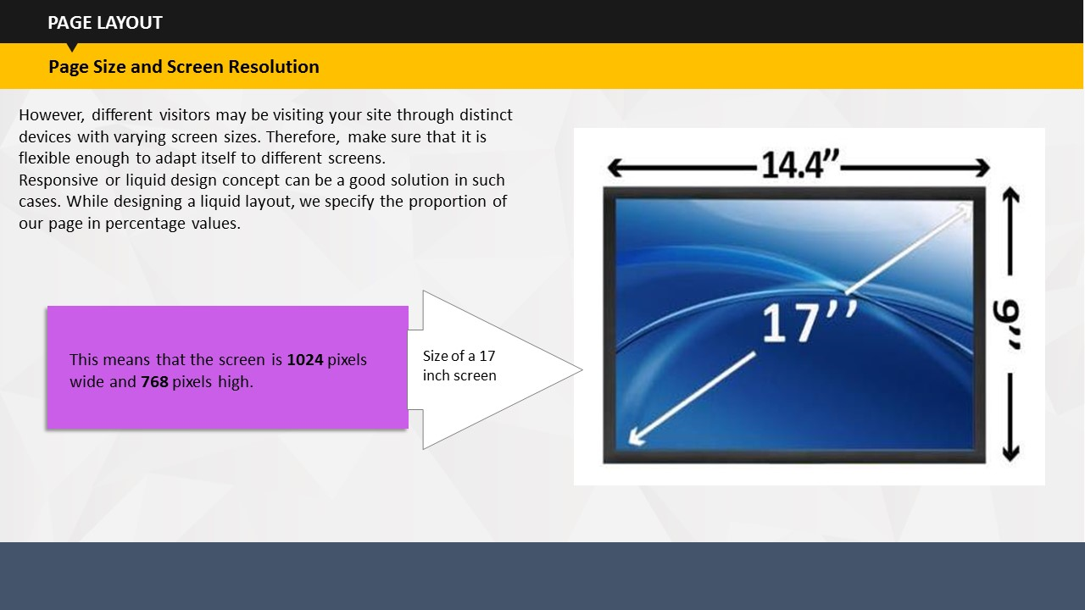

SUBTOPIC 2: PAGE SIZE AND SCREEN RESOLUTION

Today, we have PCs of distinct screen sizes and resolutions. Where in the resolution of a screen means pixel per inch.

However, distinct visitors may be visiting your site through distinct devices with varying screen sizes. Therefore, when you plan a site, make sure that it is flexible enough to adapt itself to different screens.

For instance, if you want set width of your Web page in proportion to the Website’s width, i.e. 75% of the width of the Web browser, then the page border will adjusts itself accordingly without losing content.

However, distinct visitors may be visiting your site through distinct devices with varying screen sizes. Therefore, make sure that it is flexible enough to adapt itself to different screens.

Responsive or liquid design concept can be a good solution in such cases. While designing a liquid layout, we specify the proportion of our page in percentage values.

**Your Space:**

|  |
| --- |
|  |
|  |
|  |

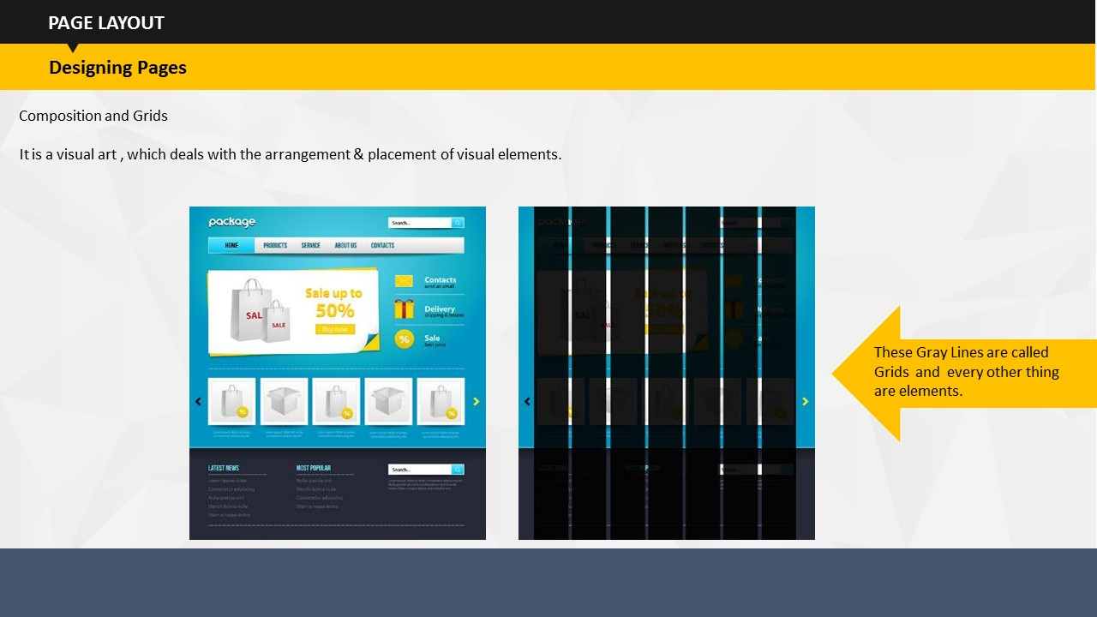

SUBTOPIC 3: DESIGNING PAGES

Composition is a visual art , which deals with the arrangement & placement of visual elements. It is important to distinguish between the use of the word elements in terms of designing pages (where it means items on the page such as navigation, branding, articles/products, and so on) and the more technical use of the word (because an element can also mean a pair of tags and their content, such as a

< b > bold < /b > element).

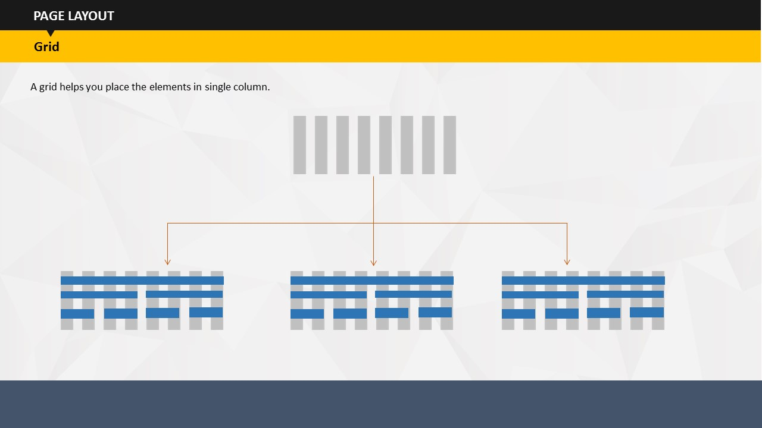

A grid helps you place the elements in single column

**Your Space:**

|  |
| --- |
|  |
|  |
|  |

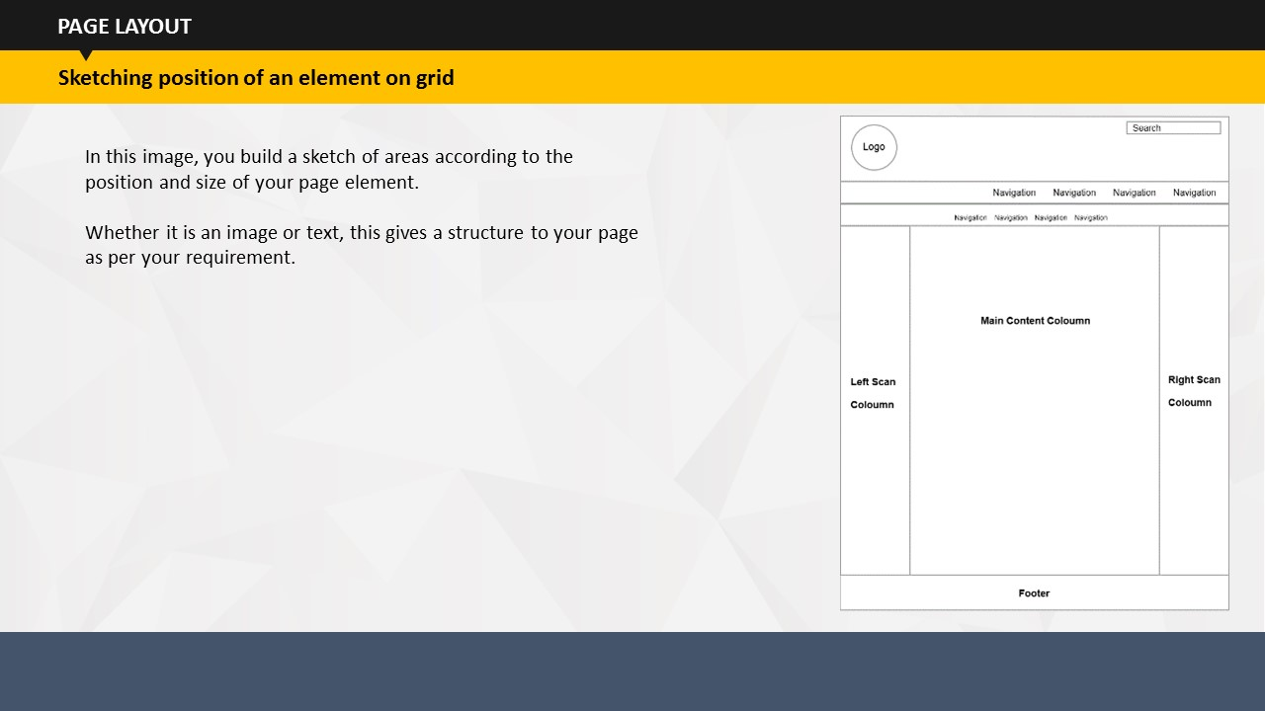

SUBTOPIC 4: SKETCHING POSITION OF AN ELEMENT ON GRID

In this image, you build a sketch of areas according to the position and size of your page element.

Weather it is an image or text, this gives a structure to your page as per your requirement.

**Your Space:**

|  |
| --- |
|  |
|  |
|  |
|  |
|  |
|  |
|  |

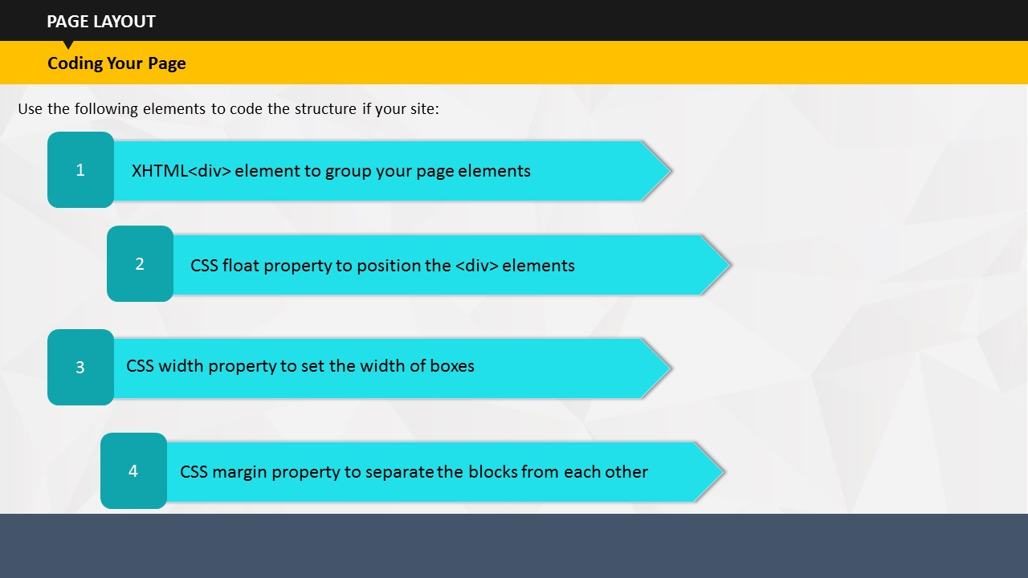

SUBTOPIC 5: CODING YOUR PAGE

Use the following elements to code the structure if your site:

* XHTML<div> element to group your page elements
* CSS float property to position the <div> elements
* CSS width property to set the width of boxes
* CSS margin property to separate the blocks from each other

**Your Space:**

|  |
| --- |
|  |
|  |
|  |
|  |
|  |
|  |
|  |

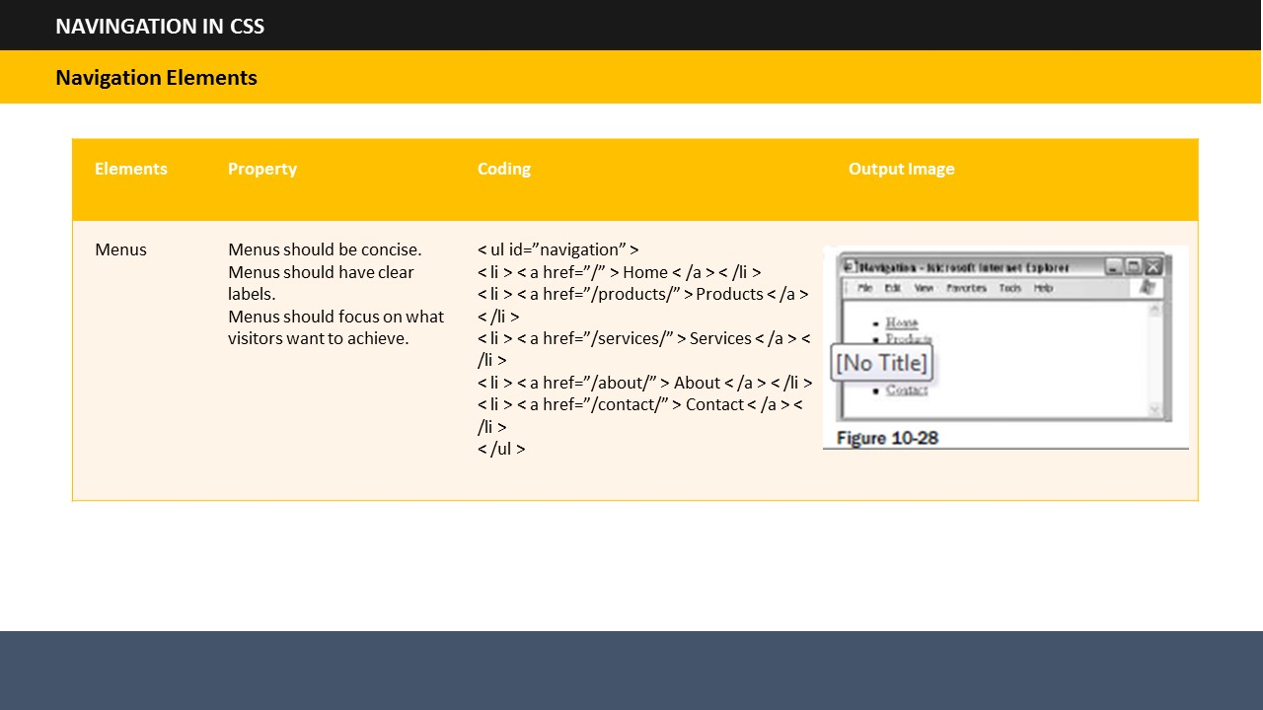

SUBTOPIC 1: NAVIGATION ELEMENTS

TOPIC 6 – NAVIGATION IN CSS

Discuss the navigation elements shown in the table.

A user navigates the site in one of three ways:

* Using provided menu
* Browsing through the links provided in text and other parts of the page
* Searching for relevant items of information

**Your Space:**

|  |
| --- |
|  |
|  |
|  |
|  |
|  |
|  |
|  |

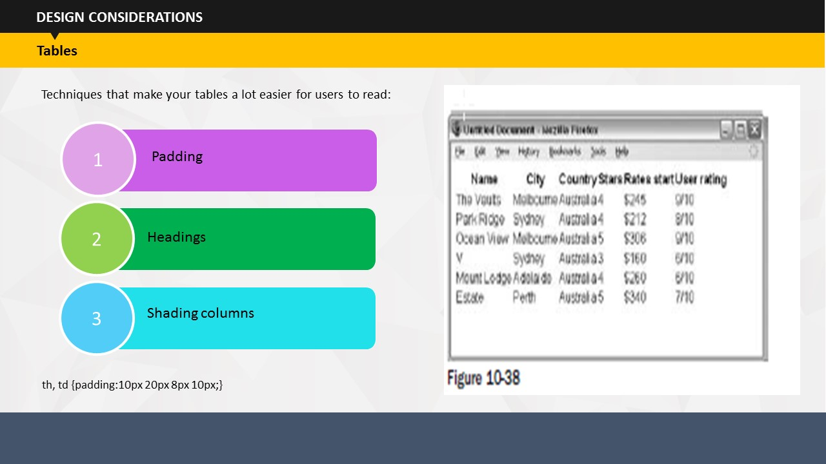

SUBTOPIC 1: TABLES

TOPIC 7 – DESIGN CONSIDERATIONS

Allowing padding around each item is important so that there is space between each cell in the table and between the contents of cell or any border, if they are used. When the content of table cells is allowed to touch either the neighboring cells or the edges of any cells, Padding becomes difficult.

These techniques make your tables a lot easier for users to read:

* Padding
* Headings
* Shading columns

Padding: th, td {padding:10px 20px 8px 10px;}

**Your Space:**

|  |
| --- |
|  |
|  |
|  |

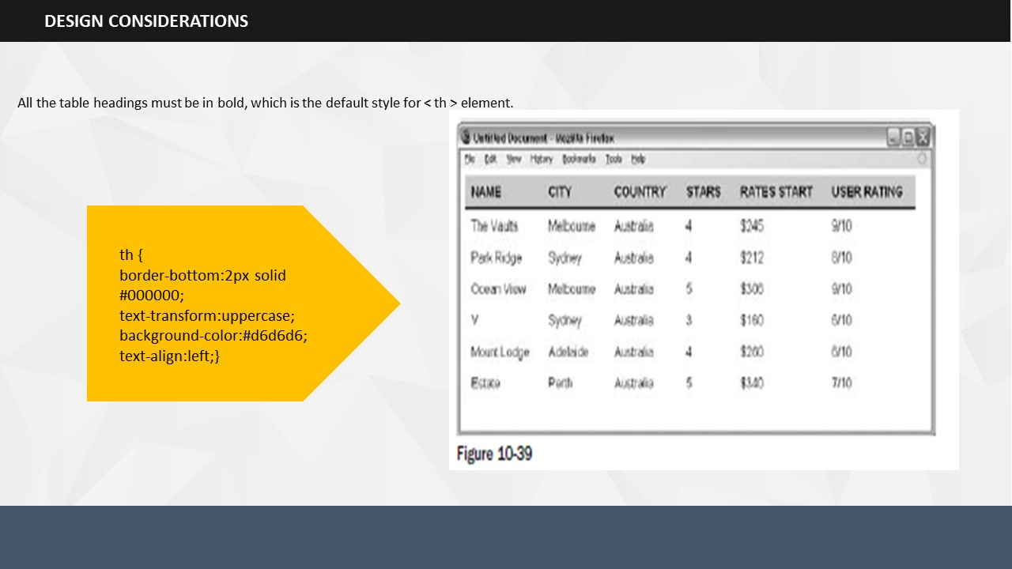

SUBTOPIC 2: HEADINGS

Try to make headers uppercase and underline the headings with a dark line to separate the headings from the content:

All the table headings must be in bold, which is the default style for < th > element.

th {

border-bottom:2px solid #000000;

text-transform:uppercase;

background-color:#d6d6d6;

text-align:left;}

**Your Space:**

|  |
| --- |
|  |
|  |
|  |
|  |

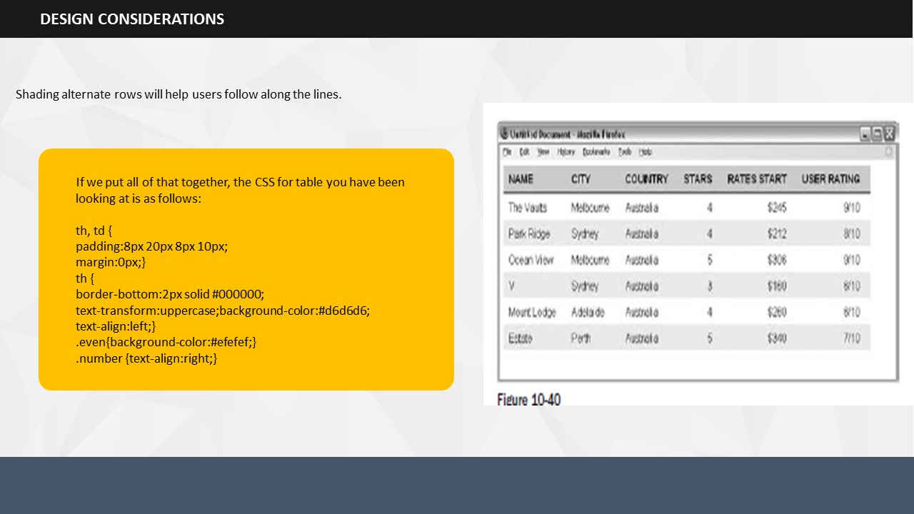

Shading alternate rows will help users follow along the lines.

SUBTOPIC 3: SHADING ALTERNATE ROWS

You should only shade every other line, preferably using a slightly lighter shade than the heading, as shown in Figure 10 - 40. You might also find it helpful to align numerical data to the right of the column and leave words aligned to the left.

If we put all of that together, the CSS for table you have been looking at is as follows:

th, td {

padding:8px 20px 8px 10px;

margin:0px;}

th {

border-bottom:2px solid #000000;

text-transform:uppercase;background-color:#d6d6d6;

text-align:left;}

.even{background-color:#efefef;}

.number {text-align:right;}

**Your Space:**

|  |
| --- |
|  |
|  |
|  |
|  |
|  |
|  |
|  |

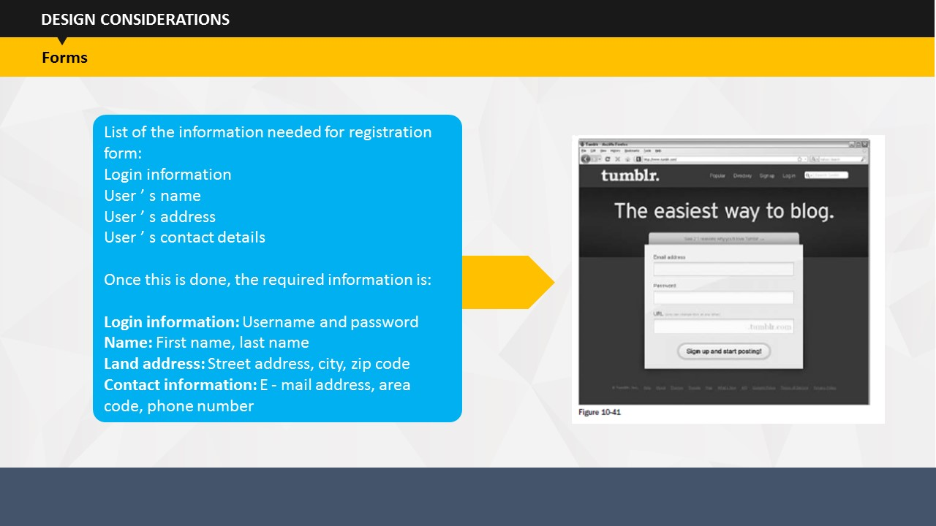

SUBTOPIC 4: FORMS

As far as designing of form is concerned, you need to be particular about its look. If your site includes a form, it needs to have good design, otherwise people won’t fill it.

List of the information needed for registration form:

Login information

User ’ s name

User ’ s address

User ’ s contact details

Once this is done, the required information is:

**Login information:** Username and password

**Name:** First name, last name

**Land address:** Street address, city, zip code

**Contact information:** E - mail address, area code, phone number

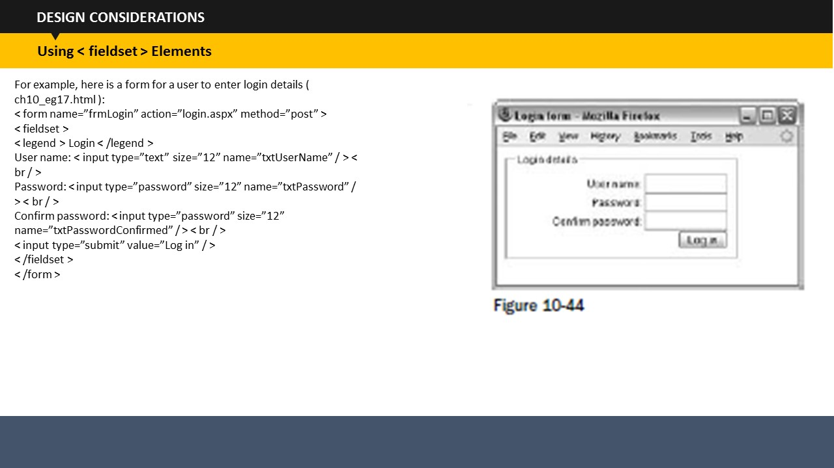

Using <fieldset> elements

For example, here is a form for a user to enter login details ( ch10_eg17.html ):

< form name=”frmLogin” action=”login.aspx” method=”post” >

< fieldset >

< legend > Login < /legend >

User name: < input type=”text” size=”12” name=”txtUserName” / > < br / >

Password: < input type=”password” size=”12” name=”txtPassword” / > < br / >

Confirm password: < input type=”password” size=”12”

name=”txtPasswordConfirmed” / > < br / >

< input type=”submit” value=”Log in” / >

< /fieldset >

< /form >

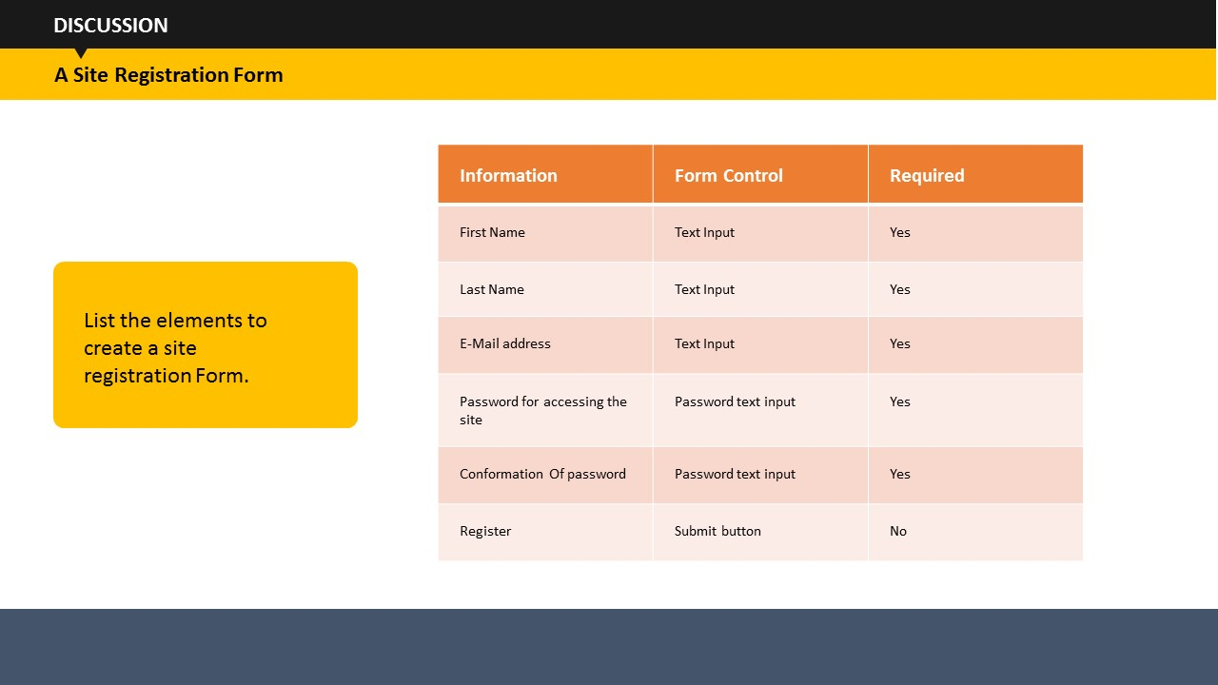

**Discussion:** List the elements to create a site registration Form.

Ask the students to create a list of elements that are required to design a site registration form.

**Your Space:**

|  |
| --- |
|  |
|  |
|  |
|  |
|  |
|  |
|  |

TOPIC 8 – USING INLINE CSS

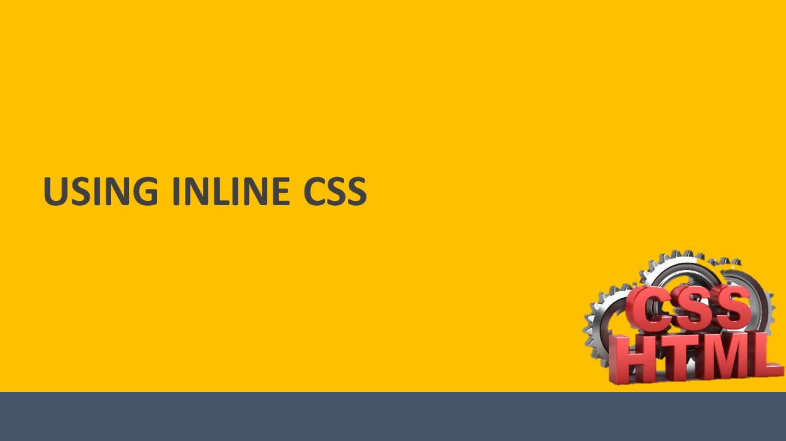

SUBTOPIC 1: WHAT IS AN INLINE CSS?

The inline style is used to apply a unique style on an element. But, it is advised to use this style sparingly otherwise it defeats the true purpose of having a style sheet in place if you have to define a unique style for every other element.

**Your Space:**

|  |
| --- |
|  |
|  |
|  |
|  |
|  |
|  |
|  |
|  |

To use inline styles, add the style attribute to the relevant tag.

**Your Space:**

|  |
| --- |
|  |
|  |
|  |
|  |
|  |
|  |
|  |
|  |

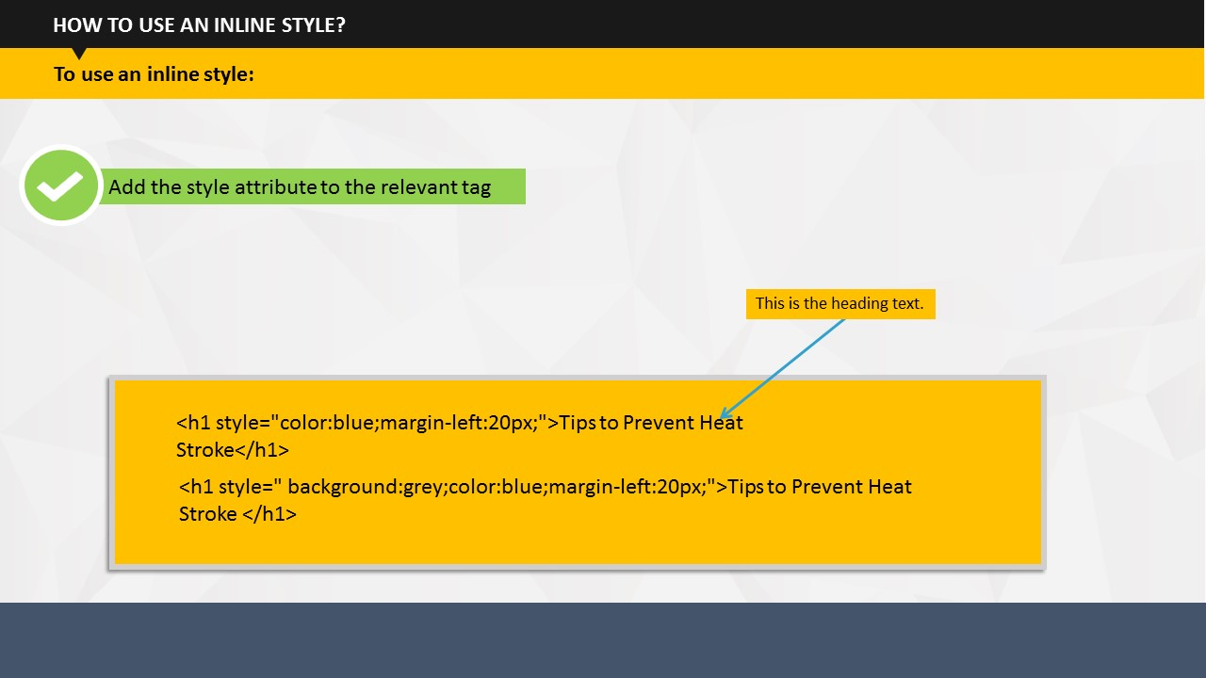

SUBTOPIC 2: HOW TO USE AN INLINE STYLE?

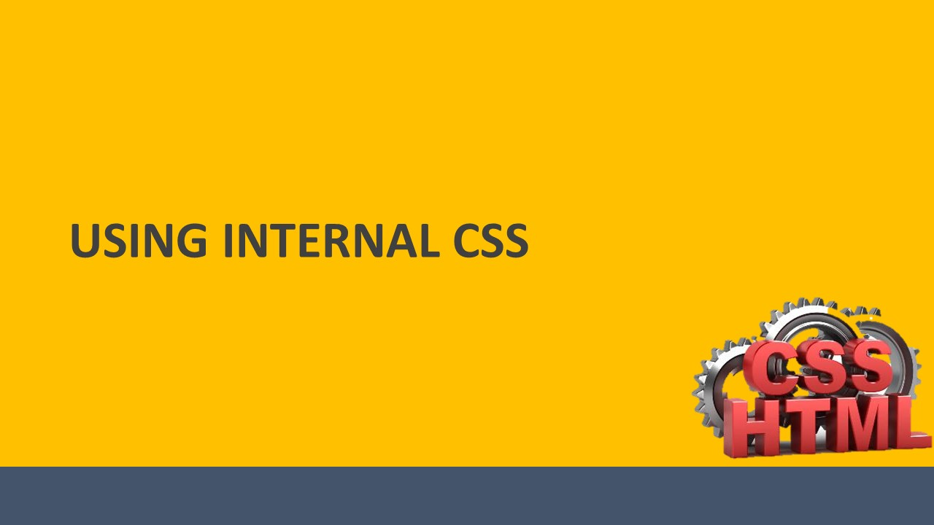

TOPIC 9: USING INTERNAL CSS

# 

SUBTOPIC 1: WHAT IS AN INTERNAL CSS?

We use an internal CSS to incorporate a unique style to a single page. This is where it differs from an inline CSS which is used to apply a unique style to an element.

**Your Space:**

|  |
| --- |
|  |
|  |
|  |
|  |
|  |
|  |
|  |
|  |

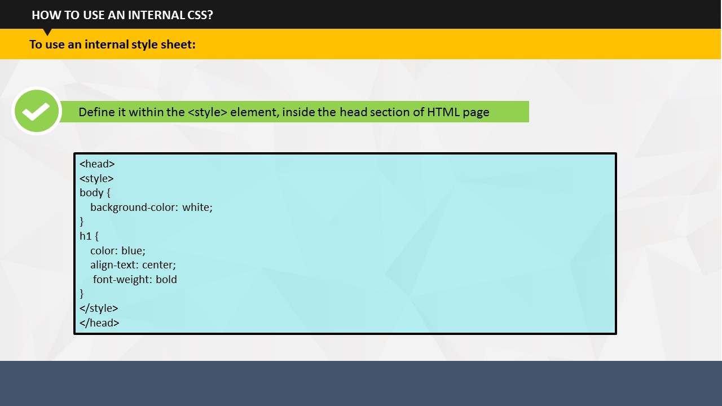

SUBTOPIC 2: HOW TO USE AN INTERNAL CSS?

* To use an internal CSS, you should define it within the <style> element, inside the head section of HTML page.
* The following example shows the specific style of a page in terms of background color and page heading.

<head>  
<style>  
body {  
    background-color: white;  
}  
h1 {  
    color: blue;  
    align-text: center;  
 font-weight: bold  
}   
</style>  
</head>

Internal CSS are really helpful if you want to style only one page and even if you want different pages to follow different styles.

**Your Space:**

|  |
| --- |
|  |
|  |
|  |
|  |
|  |
|  |
|  |
|  |

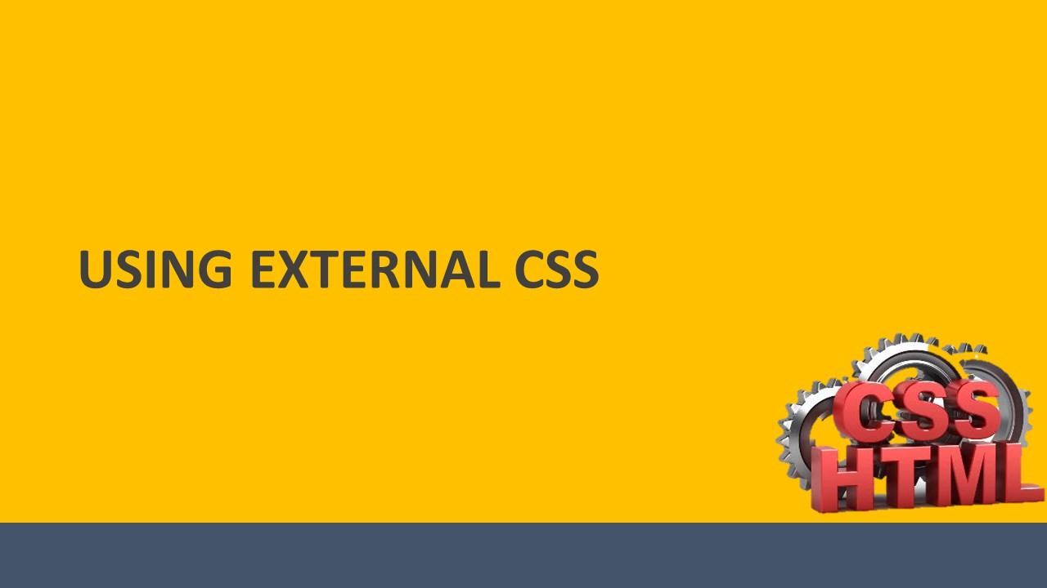

TOPIC 10 – USING EXTERNAL CSS

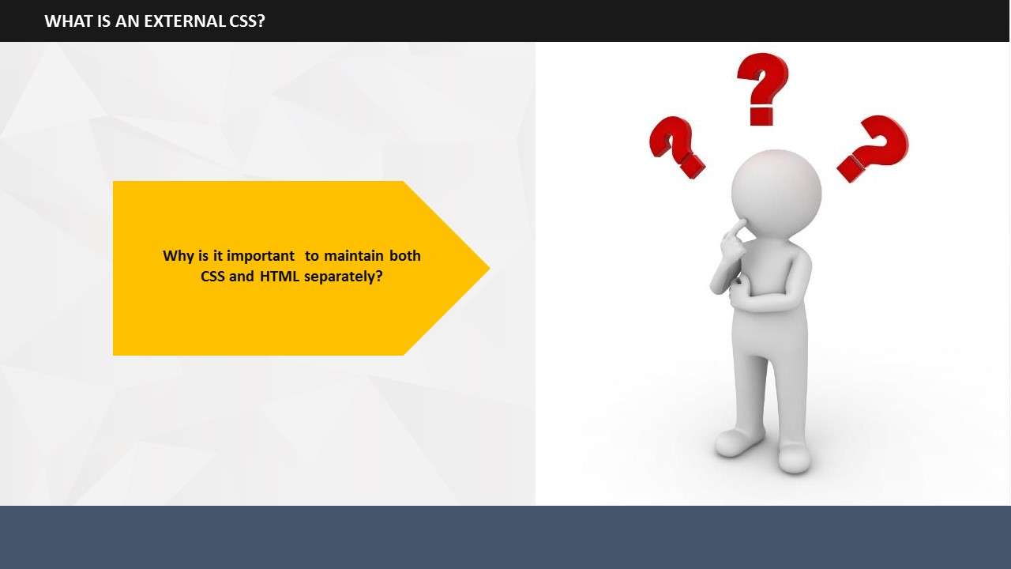

# 

SUBTOPIC 1: WHAT IS AN EXTERNAL CSS?

An external style sheet maintains both CSS and HTML separately.

**Your Space:**

|  |
| --- |
|  |
|  |
|  |
|  |
|  |
|  |
|  |

Why is it important to maintain both CSS and HTML separately?

The files help in maintaining the content part and the design of page separately. So, if you wish to change the look and feel of a website, you just need to update the CSS part! In addition, it’s quite easy to reuse the codes if your CSS file is separate from HTML.

**Your Space:**

|  |
| --- |
|  |
|  |
|  |
|  |
|  |
|  |
|  |
|  |

1. 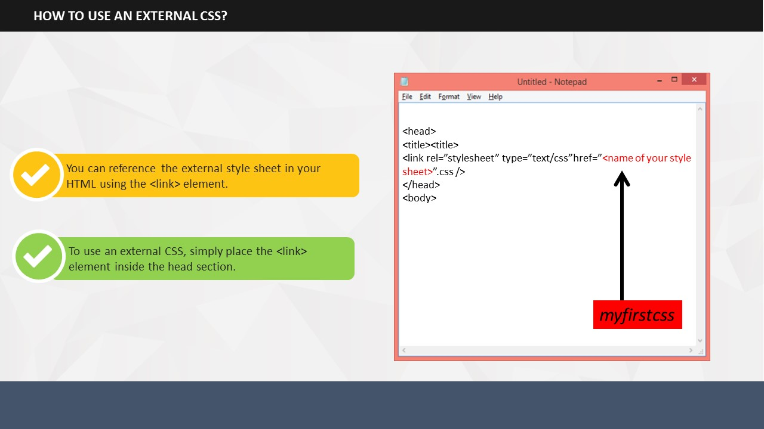An external style sheet contains only CSS code. You can recognize such files by their file extension, which is ".css". You can reference the external style sheet in your HTML using the <link> element. To use an external CSS, simply place the <link> element inside the head section.

SUBTOPIC 2: HOW TO USE AN EXTERNAL CSS?

1. To insert an external sheet enter its name in place of the red highlighted text as shown below:

<head>  
<title><title>  
<link rel=”stylesheet” type=”text/css”href=”<name of your style sheet>”.css />  
</head>  
<body>

**Your Space:**

|  |
| --- |
|  |
|  |
|  |

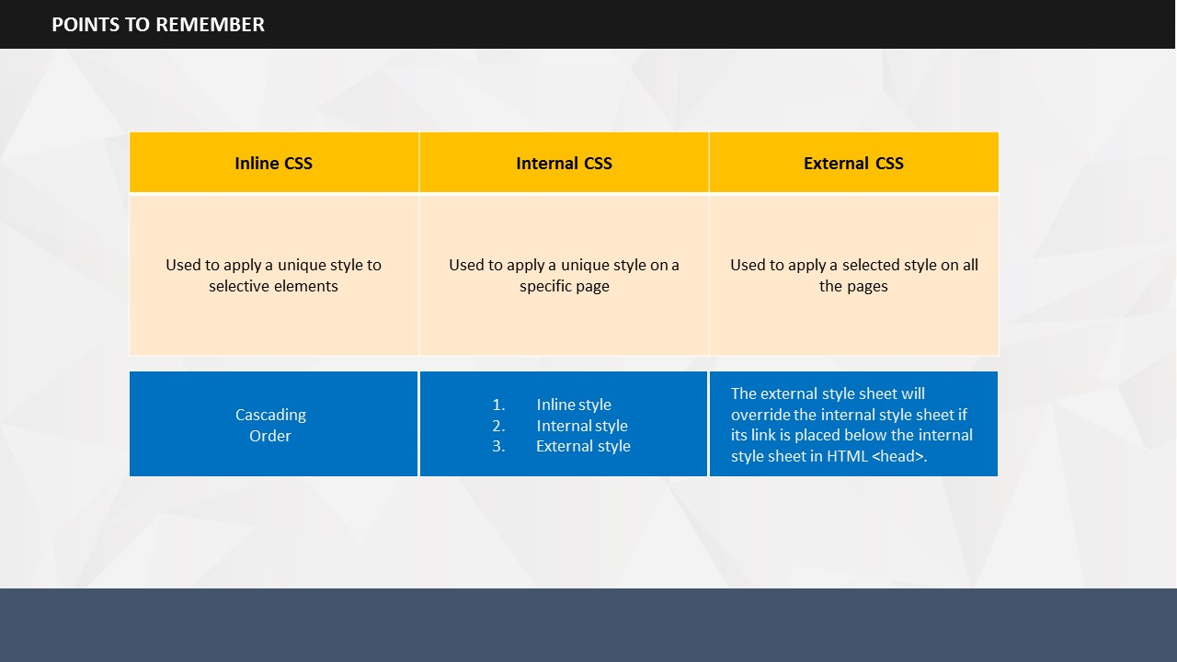

SUBTOPIC 3: POINTS TO REMEMER

* To apply a unique style to an element, use an inline style.
* To apply a style at a page level an internal CSS is used.
* To apply a style to all the pages, use an external CSS.
* When all the three types of style sheets are present the cascading order would be such that the inline style would have the highest priority followed by the internal style sheet and the external style sheet.
* On placing the link to the external CSS below the internal CSS in HTML <head>, the external style sheet will override the internal style sheet.

**Your Space:**

|  |
| --- |
|  |
|  |
|  |
|  |
|  |

# 

SUBTOPIC 1: RECAP

TOPIC 11 – MODULE SUMMARY

# Duration: 10 Minutes

It’s time to review what we have learned so far. Write in the space given in this guide, what you have learned today.

**Your Space:**

|  |
| --- |
|  |
|  |
|  |
|  |
|  |
|  |
|  |
|  |
|  |
|  |
|  |
|  |
|  |
|  |
|  |
|  |
|  |



This is the end of this session on CSS.

**Your Space:**

SUBTOPIC 2: FINAL TIPS AND SUMMARIZATION

|  |
| --- |
|  |
|  |
|  | |
|  | |
|  | |
|  | |
|  | |



**ITES Functional Skills Training**

# LAB EXERCISES

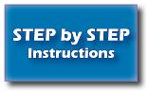

**Say**:

* You may want to bring your learner guide to labs to refer to the content and examples.
* If you have a question, you can ask me for help, or look at your learner guide or lecture slides.
* I encourage you to talk to your classmates; it is okay to share code and ideas during lab.
* You are not expected to finish all the exercises. Just do as much as you can in the allotted time. While you don't *need* to finish the rest after you leave the lab, you *should* attempt to do so, if possible.
* Before you leave, check with me to get credit for your work.

As the first exercise today, you will create a simple style sheet using any simple text editor (Notepad, WordPad etc.).



**Exercise 1**: **Creating a CSS (2 hours)**

The following section describes this exercise. Please read them all and start.

Create a CSS with the style details such as:

* Background color
* Heading (h1):
  + Font-Style
  + Color
  + Alignment
* Paragraph (p):
  + Font-Style
  + Color
  + Alignment

Next, save your CSS with your name and then preview in the browser.

**Exercise 1**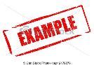

This example describes a few properties that you can add to your CSS.

* Background color: #d0e4fe
* Heading (h1):
  + Title: My First CSS
  + Color: Orange
  + Alignment: Center
* Paragraph (p):
  + Para Text: This is my first CSS exercise. This is a paragraph style.
  + Color: Blue
  + Alignment: Left

Now, create your own style sheet. All the best!

**Exercise 2: Using an External CSS (2 hours)**

Once you have created your own style sheet, use it as an external CSS.

To do this, edit the following code and attach your own style sheet to it.  
  
<html>  
<head>  
</head>

<body>  
<h1>Steve Jobs</h1>  
<p> Steven Paul "Steve" Jobs was an American entrepreneur, marketer and inventor, who was the cofounder, chairman, and CEO of Apple Inc..</p>  
  
<p> Through Apple, he was widely recognized as a charismatic and design-driven pioneer of the personal computer revolution and for his influential career in the computer and consumer electronics fields, transforming "one industry after another, from computers and smartphones to music and movies." Jobs also funded what would become Pixar Animation Studios; he became a member of the board of directors of The Walt Disney Company in 2006, when Disney acquired Pixar.</p>

</body>  
</html>

**Exercise 2** 

This example describes how you can use a style sheet externally.

<head>  
<title><title>  
<link rel=”stylesheet” type=”text/css”href=”myextrenalstylesheet”.css />  
</head>  
<body>

<h1>This is a Heading</h1>  
<p>This is a paragraph.</p>

</body>  
</html>

Now, attach your own style sheet to the given code. All the best!

|  |  |
| --- | --- |
| http://png-4.findicons.com/files/icons/1786/oxygen_refit/128/gnome_sticky_notes_applet.png | If you finish all your exercises OR the lab time is up, you may stop working. |